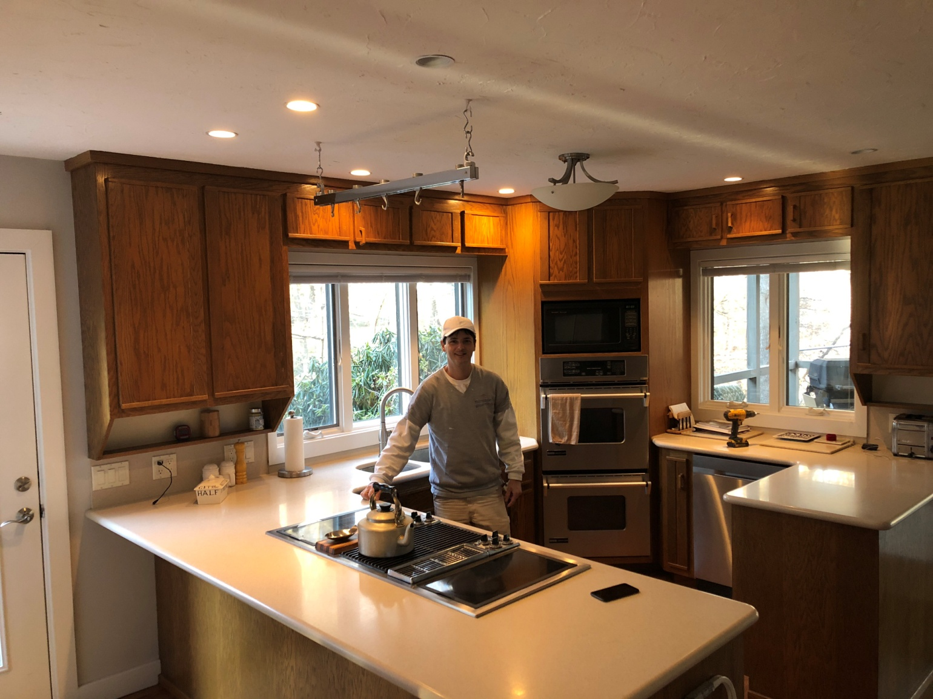
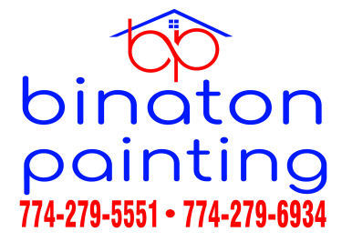

DON'T INCLUDE PAINTING INSIDE THE CABINET.
CABINETS:
COLOR SAME LIKE WITE DOORS 31Unit
STYLE OAK-WOOD FOR SMOOTH DRAWERS 11 Unit
COMPLETE JOB IN 3 WEEKS

We use only the highest quality materials.
” Thank you so much for trusting me . I do my best, taking care of your house as if it were mine. I take pleasure and love my job. “
Wellington B. Bovenschulte
Master Painter

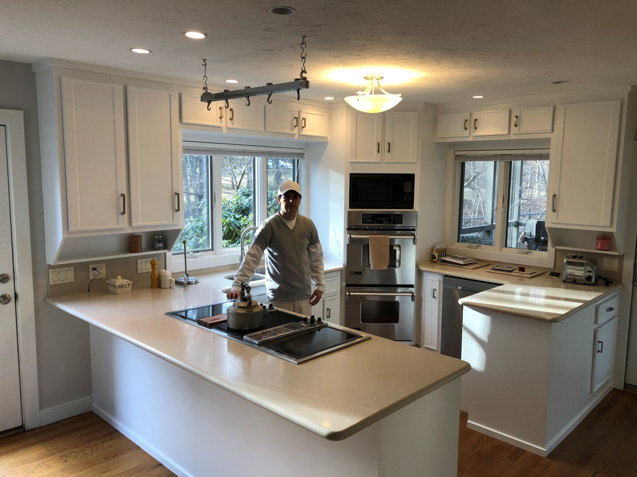

DON'T INCLUDE PAINTING INSIDE THE CABINET.
CABINETS:
COLOR SAME LIKE WITE DOORS 31Unit
STYLE OAK-WOOD FOR SMOOTH DRAWERS 11 Unit
COMPLETE JOB IN 3 WEEKS

We use only the highest quality materials.
” Thank you so much for trusting me . I do my best, taking care of your house as if it were mine. I take pleasure and love my job. “
Wellington B. Bovenschulte
Master Painter

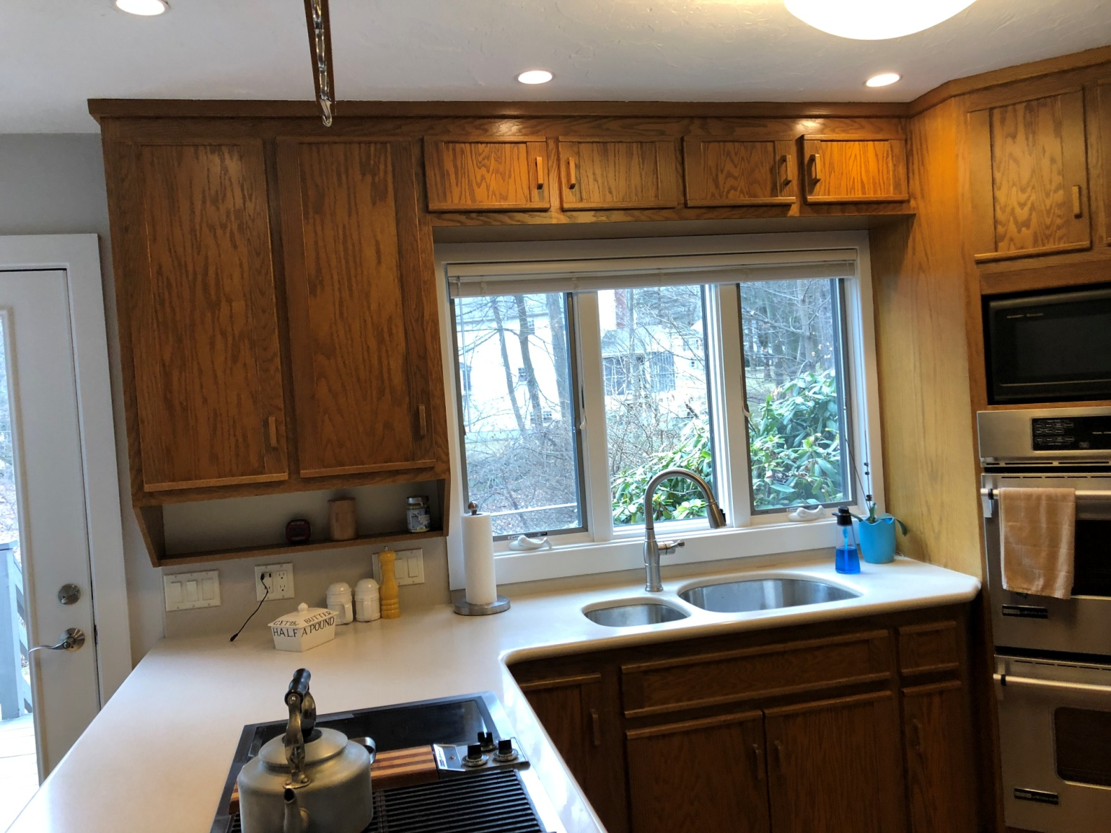

DON'T INCLUDE PAINTING INSIDE THE CABINET.
CABINETS:
COLOR SAME LIKE WITE DOORS 31Unit
STYLE OAK-WOOD FOR SMOOTH DRAWERS 11 Unit
COMPLETE JOB IN 3 WEEKS

We use only the highest quality materials.
” Thank you so much for trusting me . I do my best, taking care of your house as if it were mine. I take pleasure and love my job. “
Wellington B. Bovenschulte
Master Painter
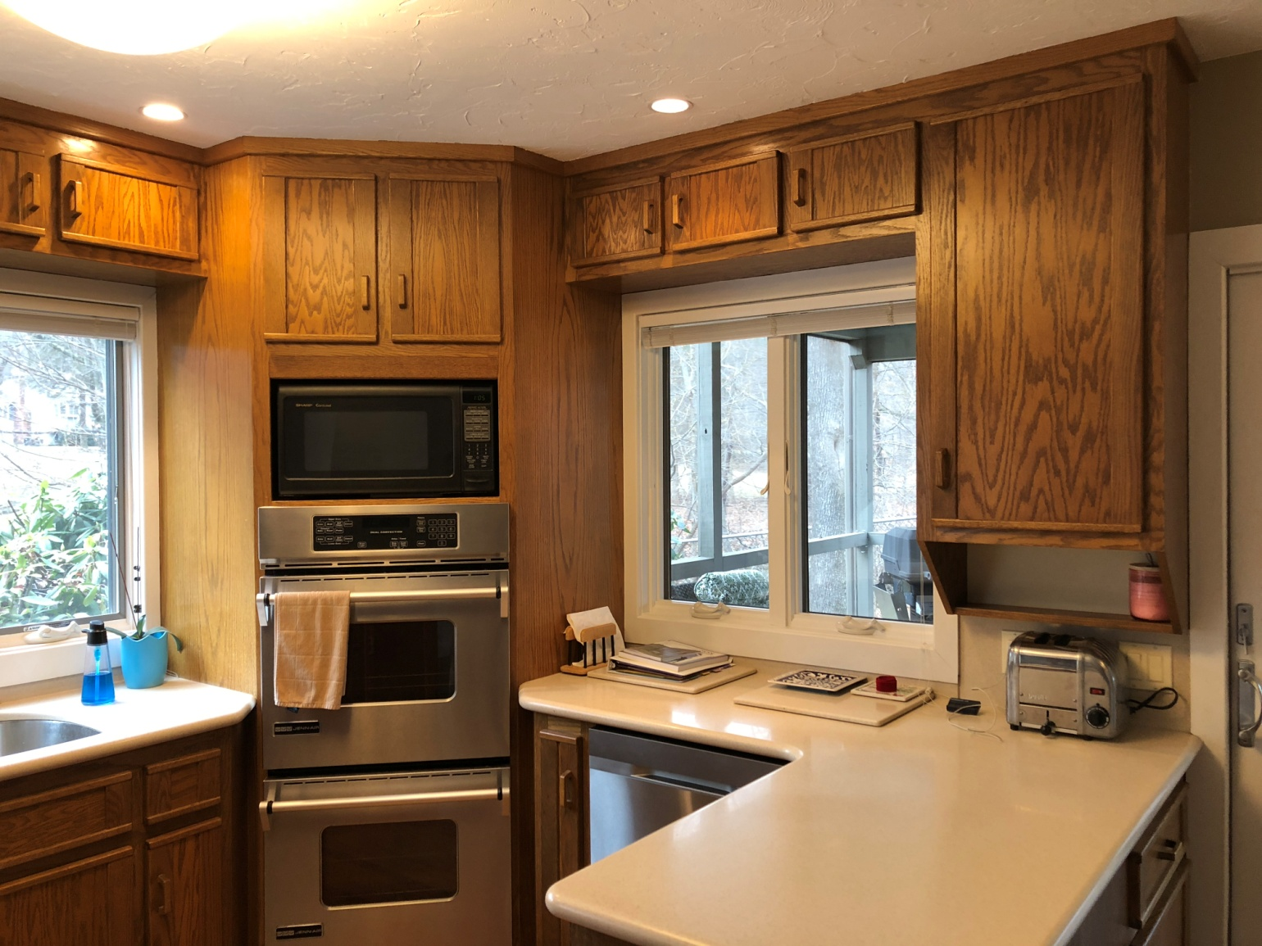

DON'T INCLUDE PAINTING INSIDE THE CABINET.
CABINETS:
COLOR SAME LIKE WITE DOORS 31Unit
STYLE OAK-WOOD FOR SMOOTH DRAWERS 11 Unit
COMPLETE JOB IN 3 WEEKS

We use only the highest quality materials.
” Thank you so much for trusting me . I do my best, taking care of your house as if it were mine. I take pleasure and love my job. “
Wellington B. Bovenschulte
Master Painter
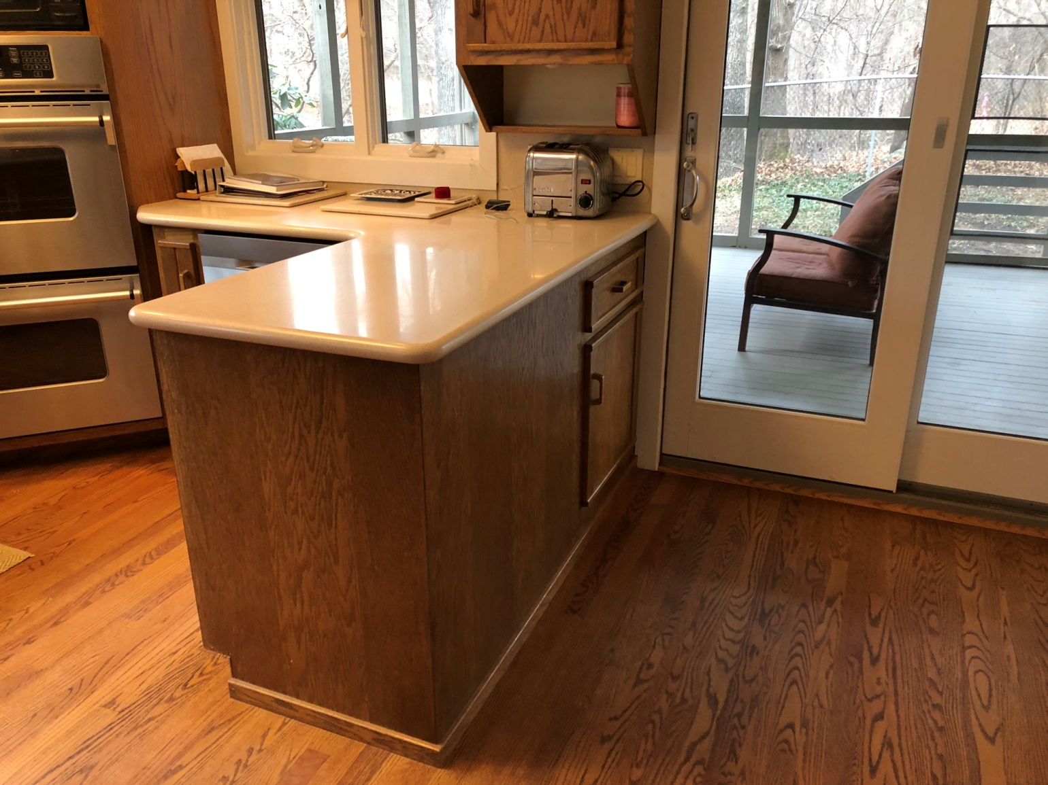

DON'T INCLUDE PAINTING INSIDE THE CABINET.
CABINETS:
COLOR SAME LIKE WITE DOORS 31Unit
STYLE OAK-WOOD FOR SMOOTH DRAWERS 11 Unit
COMPLETE JOB IN 3 WEEKS

We use only the highest quality materials.
” Thank you so much for trusting me . I do my best, taking care of your house as if it were mine. I take pleasure and love my job. “
Wellington B. Bovenschulte
Master Painter
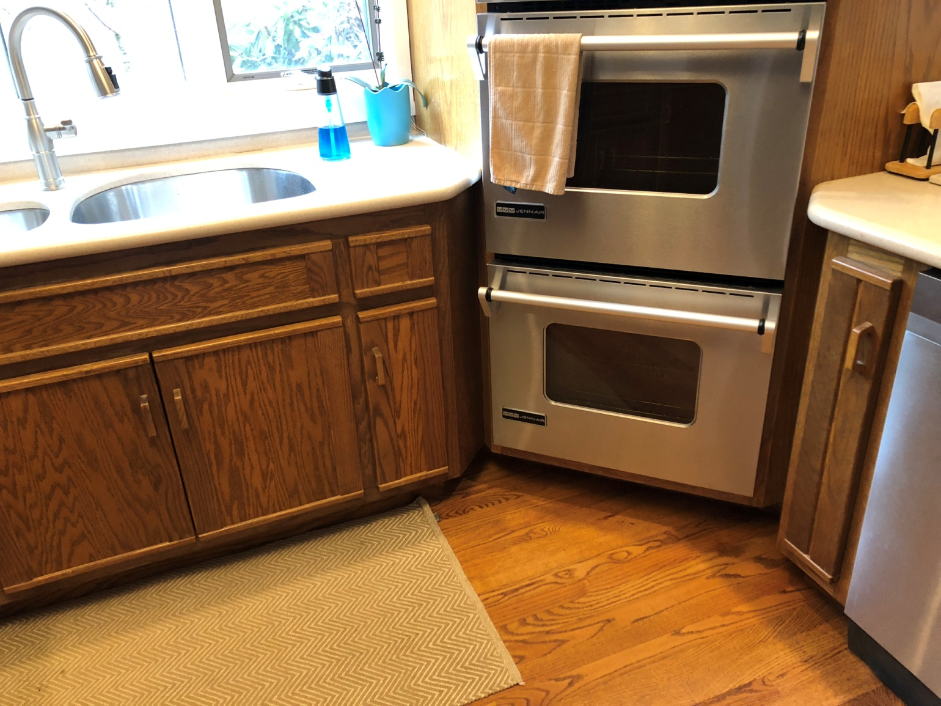

DON'T INCLUDE PAINTING INSIDE THE CABINET.
CABINETS:
COLOR SAME LIKE WITE DOORS 31Unit
STYLE OAK-WOOD FOR SMOOTH DRAWERS 11 Unit
COMPLETE JOB IN 3 WEEKS

We use only the highest quality materials.
” Thank you so much for trusting me . I do my best, taking care of your house as if it were mine. I take pleasure and love my job. “
Wellington B. Bovenschulte
Master Painter
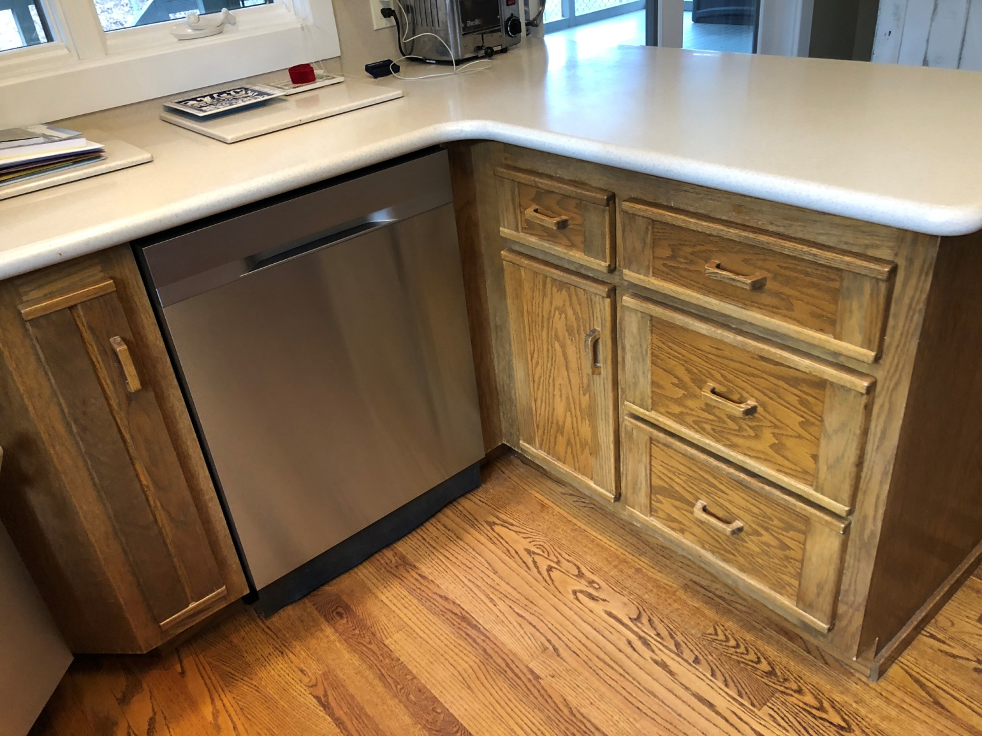

DON'T INCLUDE PAINTING INSIDE THE CABINET.
CABINETS:
COLOR SAME LIKE WITE DOORS 31Unit
STYLE OAK-WOOD FOR SMOOTH DRAWERS 11 Unit
COMPLETE JOB IN 3 WEEKS

We use only the highest quality materials.
” Thank you so much for trusting me . I do my best, taking care of your house as if it were mine. I take pleasure and love my job. “
Wellington B. Bovenschulte
Master Painter
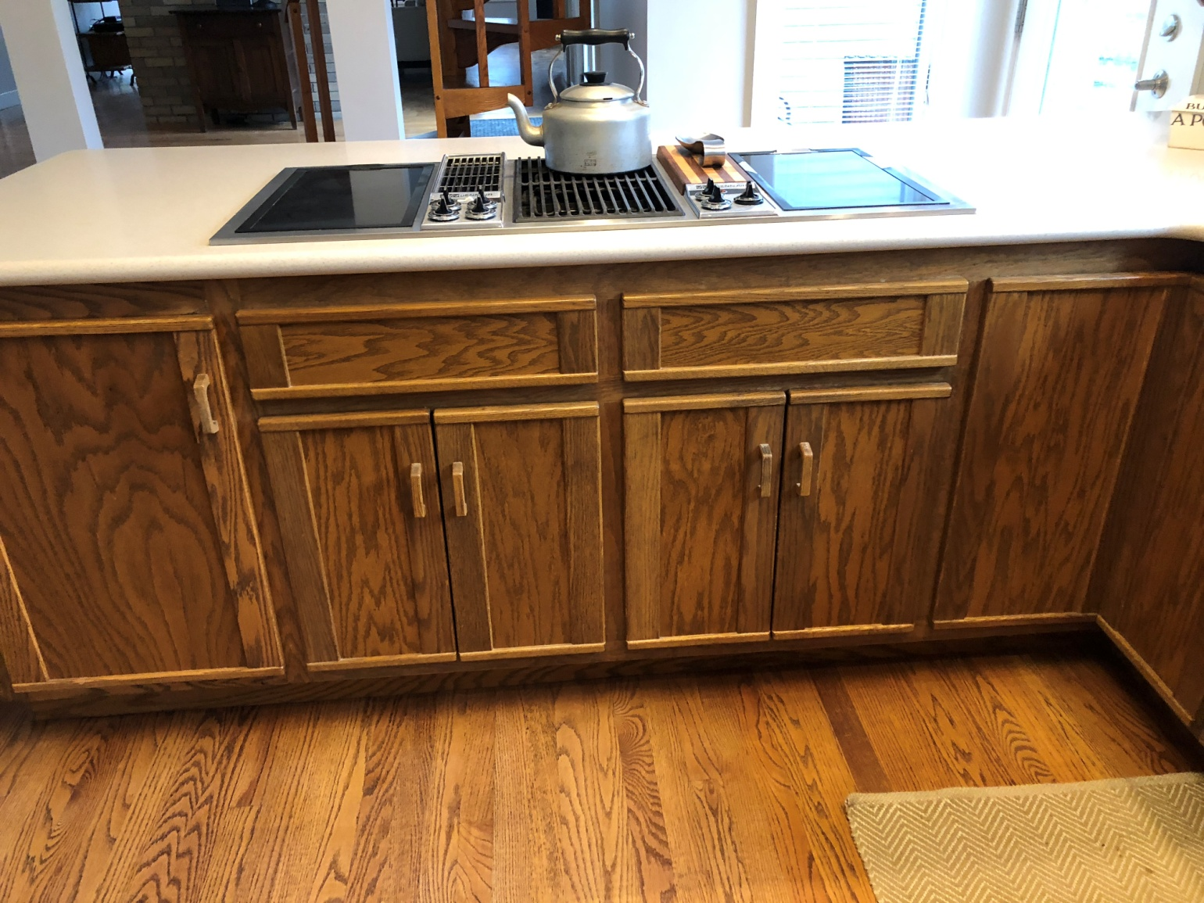

DON'T INCLUDE PAINTING INSIDE THE CABINET.
CABINETS:
COLOR SAME LIKE WITE DOORS 31Unit
STYLE OAK-WOOD FOR SMOOTH DRAWERS 11 Unit
COMPLETE JOB IN 3 WEEKS

We use only the highest quality materials.
” Thank you so much for trusting me . I do my best, taking care of your house as if it were mine. I take pleasure and love my job. “
Wellington B. Bovenschulte
Master Painter
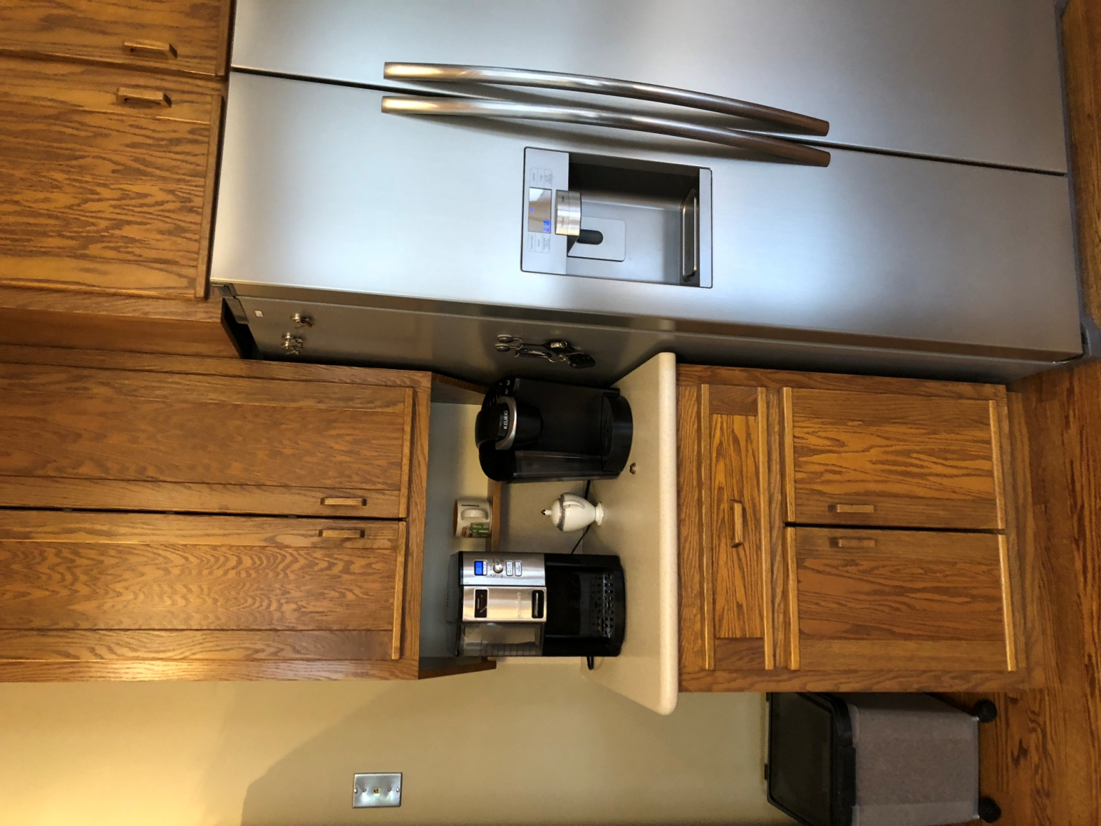

DON'T INCLUDE PAINTING INSIDE THE CABINET.
CABINETS:
COLOR SAME LIKE WITE DOORS 31Unit
STYLE OAK-WOOD FOR SMOOTH DRAWERS 11 Unit
COMPLETE JOB IN 3 WEEKS
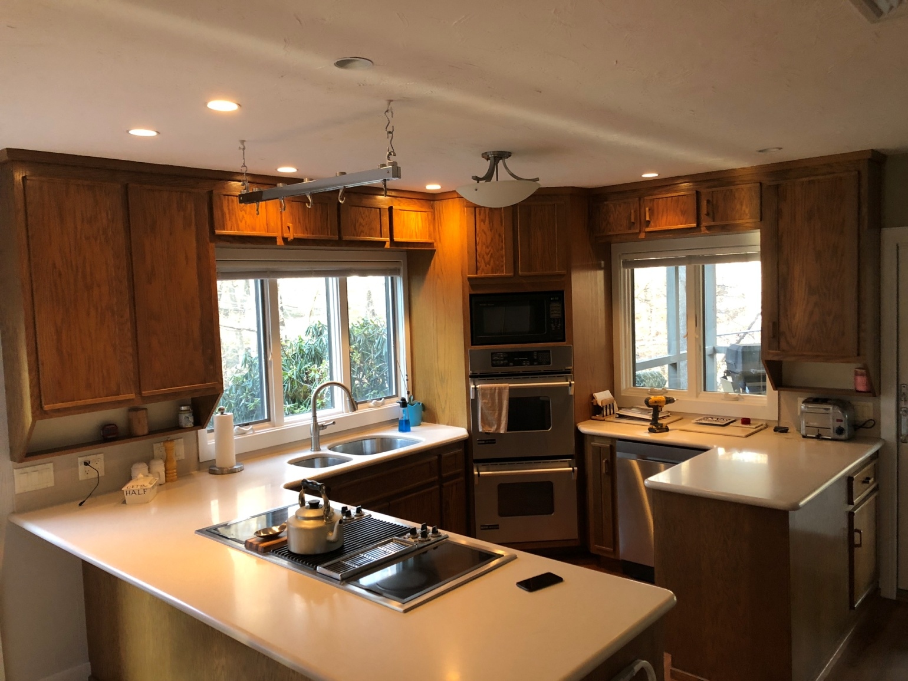

DON'T INCLUDE PAINTING INSIDE THE CABINET.
CABINETS:
COLOR SAME LIKE WITE DOORS 31Unit
STYLE OAK-WOOD FOR SMOOTH DRAWERS 11 Unit
COMPLETE JOB IN 3 WEEKS

We use only the highest quality materials.
” Thank you so much for trusting me . I do my best, taking care of your house as if it were mine. I take pleasure and love my job. “
Wellington B. Bovenschulte
Master Painter
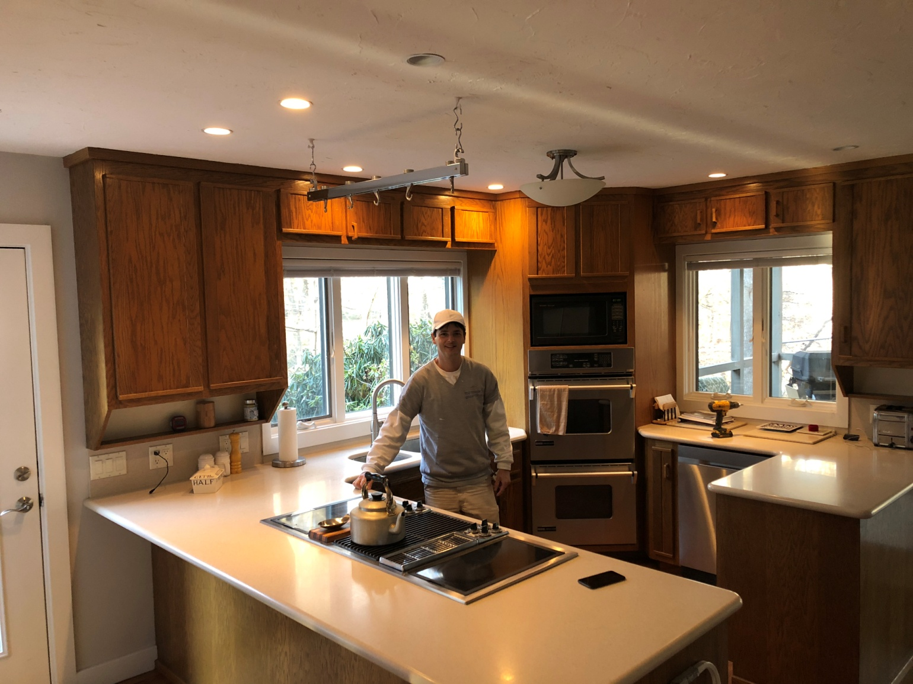

DON'T INCLUDE PAINTING INSIDE THE CABINET.
CABINETS:
COLOR SAME LIKE WITE DOORS 31Unit
STYLE OAK-WOOD FOR SMOOTH DRAWERS 11 Unit
COMPLETE JOB IN 3 WEEKS

We use only the highest quality materials.
” Thank you so much for trusting me . I do my best, taking care of your house as if it were mine. I take pleasure and love my job. “
Wellington B. Bovenschulte
Master Painter
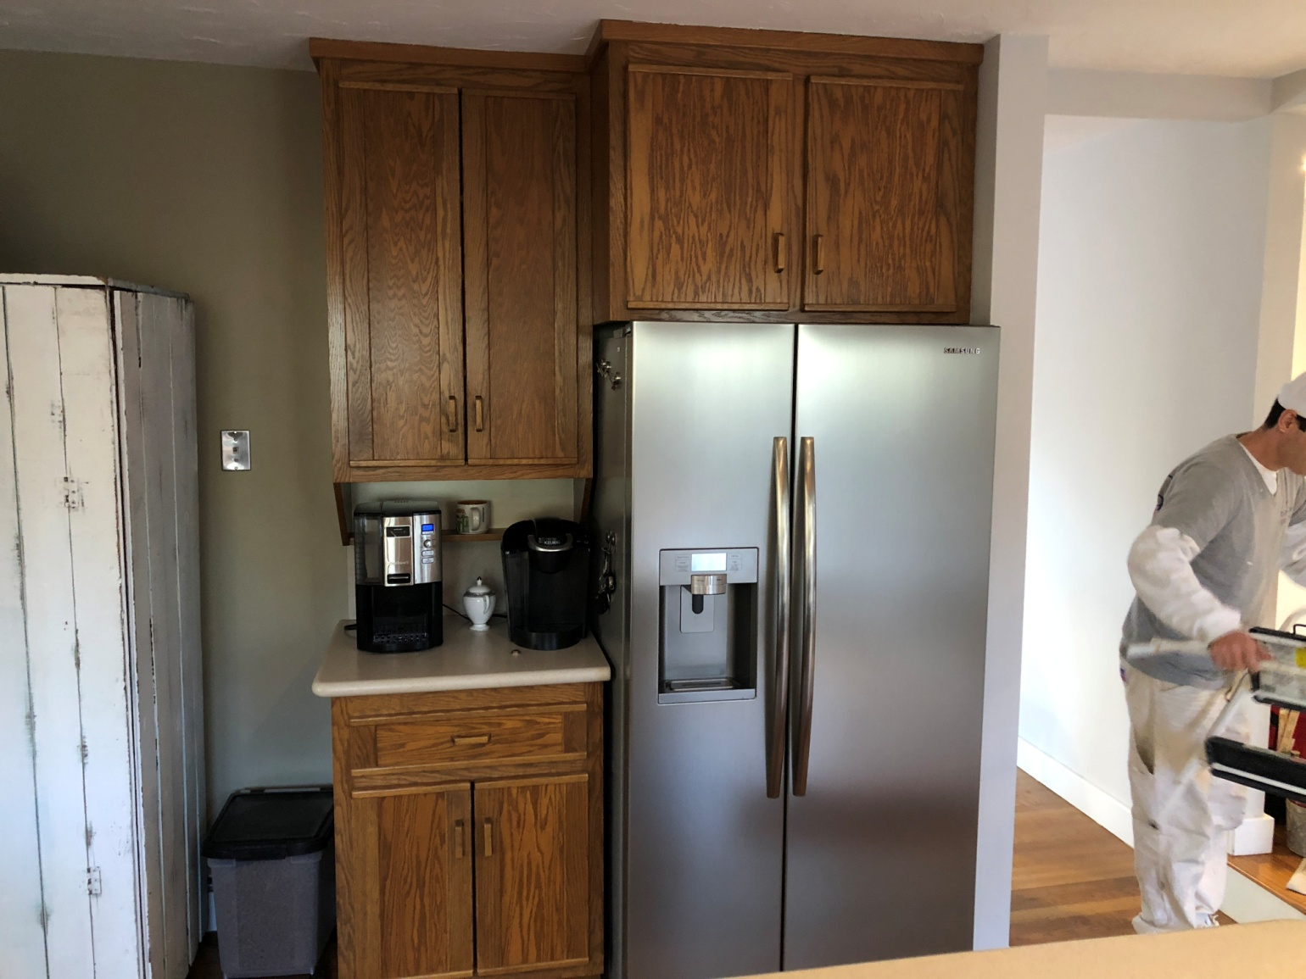

DON'T INCLUDE PAINTING INSIDE THE CABINET.
CABINETS:
COLOR SAME LIKE WITE DOORS 31Unit
STYLE OAK-WOOD FOR SMOOTH DRAWERS 11 Unit
COMPLETE JOB IN 3 WEEKS

We use only the highest quality materials.
” Thank you so much for trusting me . I do my best, taking care of your house as if it were mine. I take pleasure and love my job. “
Wellington B. Bovenschulte
Master Painter
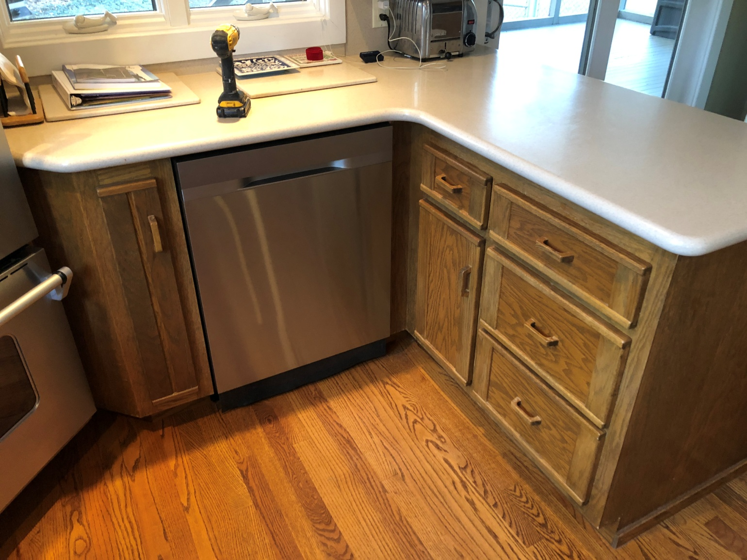

DON'T INCLUDE PAINTING INSIDE THE CABINET.
CABINETS:
COLOR SAME LIKE WITE DOORS 31Unit
STYLE OAK-WOOD FOR SMOOTH DRAWERS 11 Unit
COMPLETE JOB IN 3 WEEKS

We use only the highest quality materials.
” Thank you so much for trusting me . I do my best, taking care of your house as if it were mine. I take pleasure and love my job. “
Wellington B. Bovenschulte
Master Painter
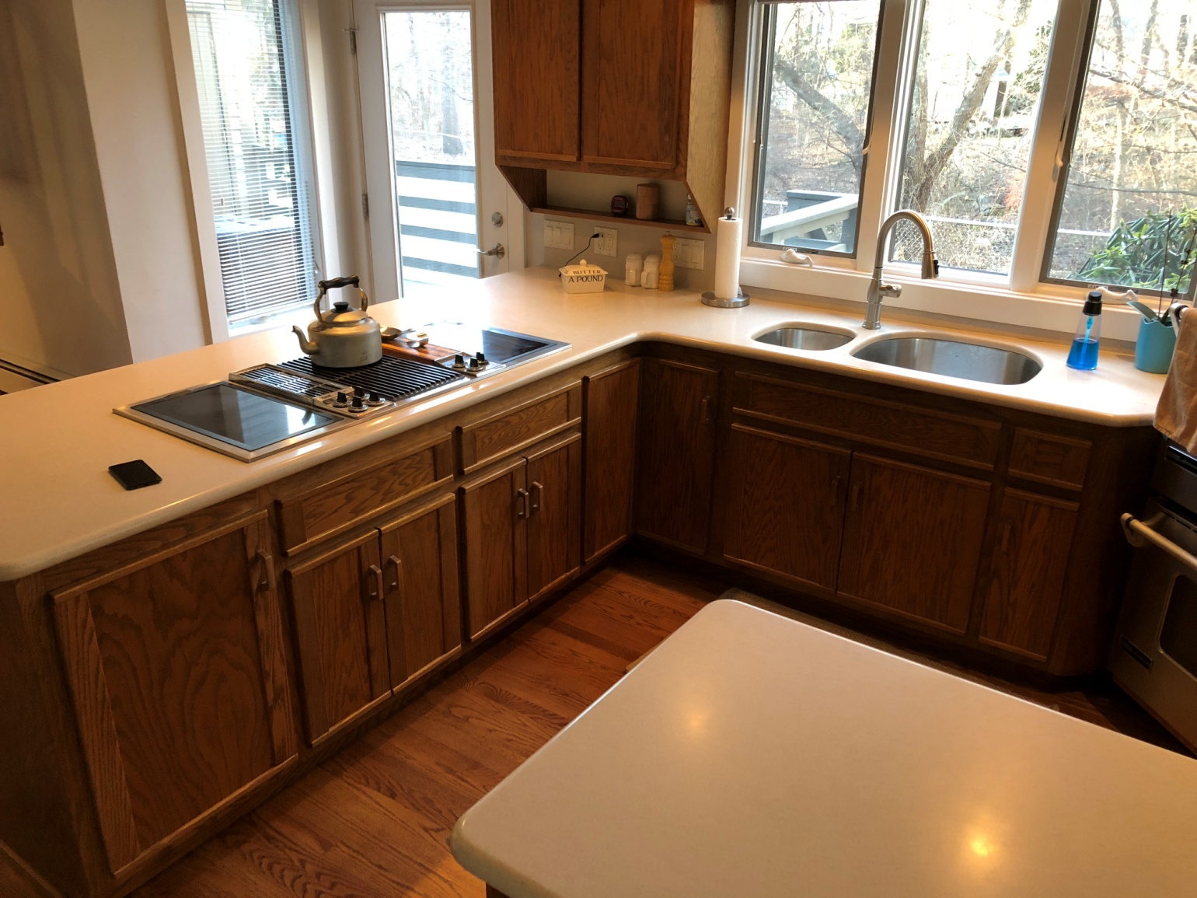

DON'T INCLUDE PAINTING INSIDE THE CABINET.
CABINETS:
COLOR SAME LIKE WITE DOORS 31Unit
STYLE OAK-WOOD FOR SMOOTH DRAWERS 11 Unit
COMPLETE JOB IN 3 WEEKS

We use only the highest quality materials.
” Thank you so much for trusting me . I do my best, taking care of your house as if it were mine. I take pleasure and love my job. “
Wellington B. Bovenschulte
Master Painter
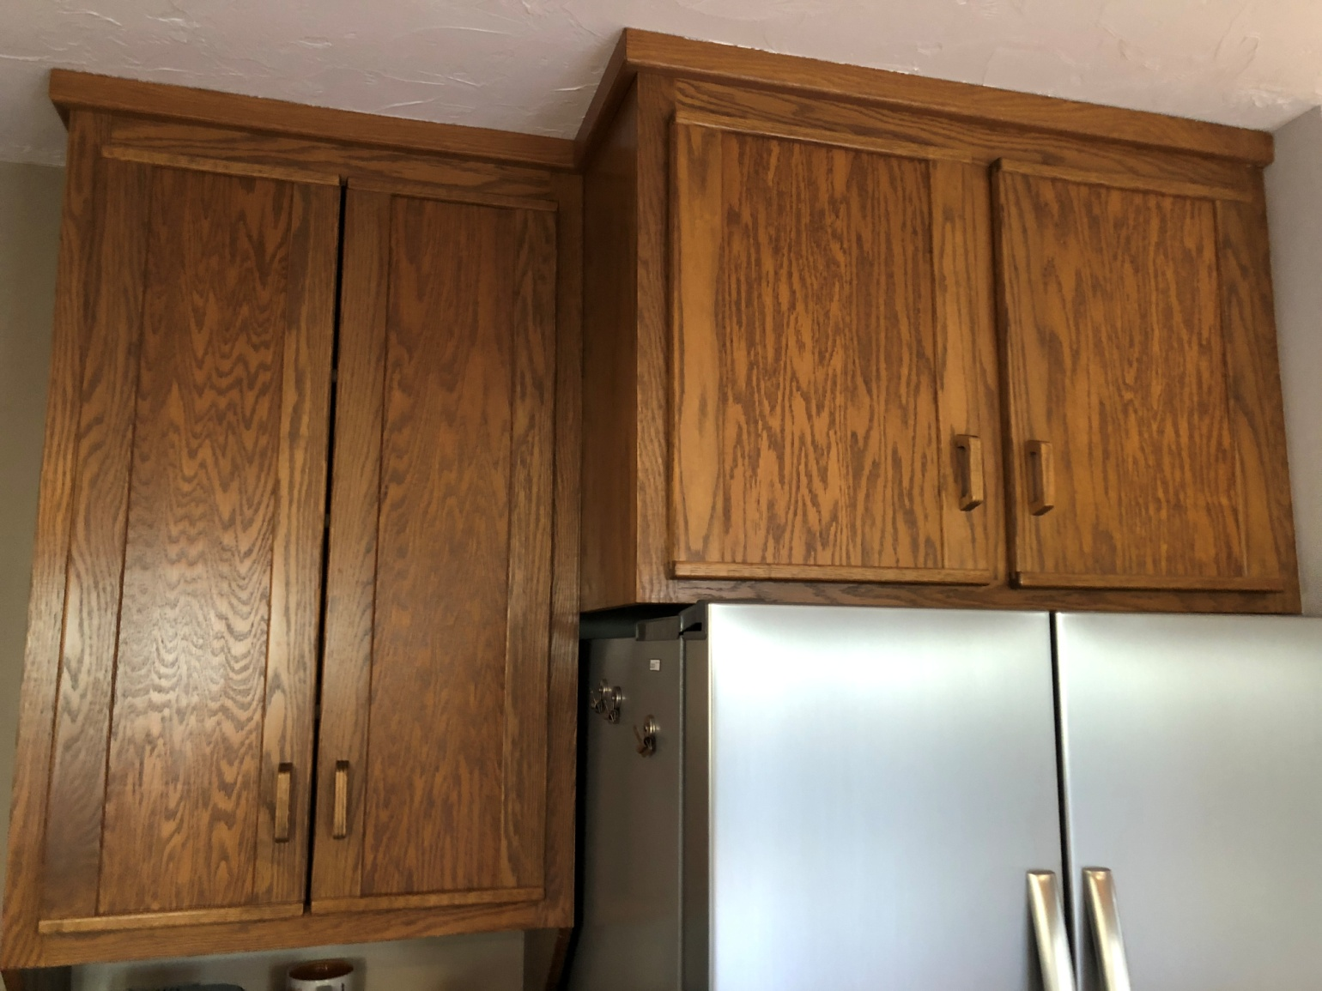

DON'T INCLUDE PAINTING INSIDE THE CABINET.
CABINETS:
COLOR SAME LIKE WITE DOORS 31Unit
STYLE OAK-WOOD FOR SMOOTH DRAWERS 11 Unit
COMPLETE JOB IN 3 WEEKS

We use only the highest quality materials.
” Thank you so much for trusting me . I do my best, taking care of your house as if it were mine. I take pleasure and love my job. “
Wellington B. Bovenschulte
Master Painter
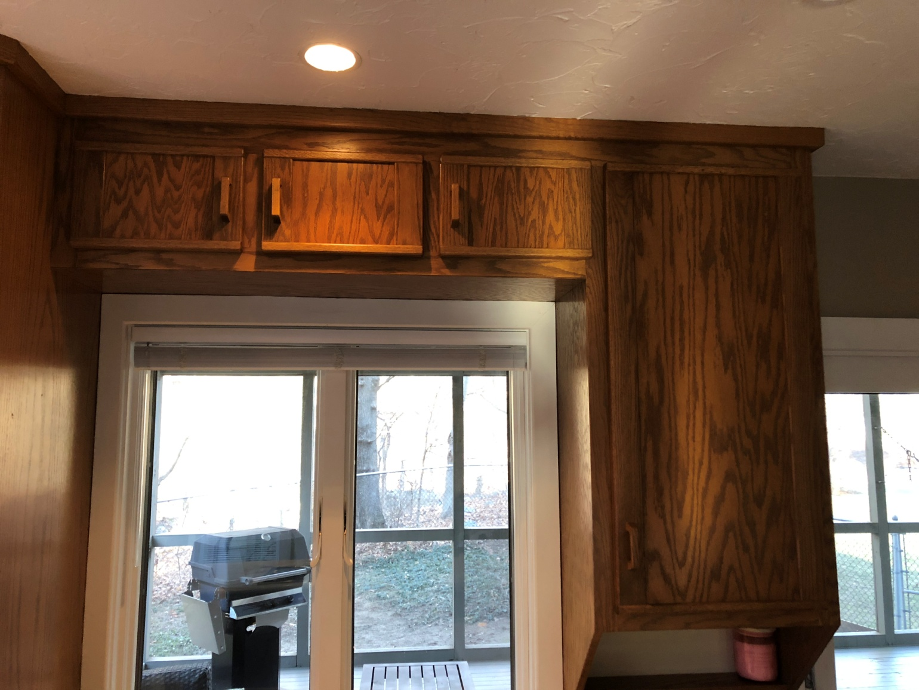

DON'T INCLUDE PAINTING INSIDE THE CABINET.
CABINETS:
COLOR SAME LIKE WITE DOORS 31Unit
STYLE OAK-WOOD FOR SMOOTH DRAWERS 11 Unit
COMPLETE JOB IN 3 WEEKS

We use only the highest quality materials.
” Thank you so much for trusting me . I do my best, taking care of your house as if it were mine. I take pleasure and love my job. “
Wellington B. Bovenschulte
Master Painter
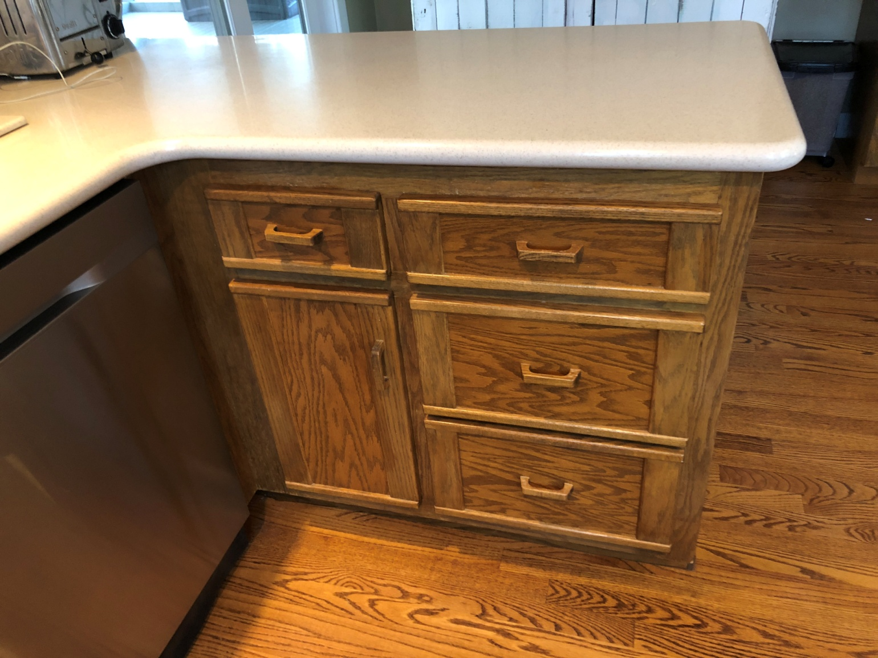

DON'T INCLUDE PAINTING INSIDE THE CABINET.
CABINETS:
COLOR SAME LIKE WITE DOORS 31Unit
STYLE OAK-WOOD FOR SMOOTH DRAWERS 11 Unit
COMPLETE JOB IN 3 WEEKS

We use only the highest quality materials.
” Thank you so much for trusting me . I do my best, taking care of your house as if it were mine. I take pleasure and love my job. “
Wellington B. Bovenschulte
Master Painter
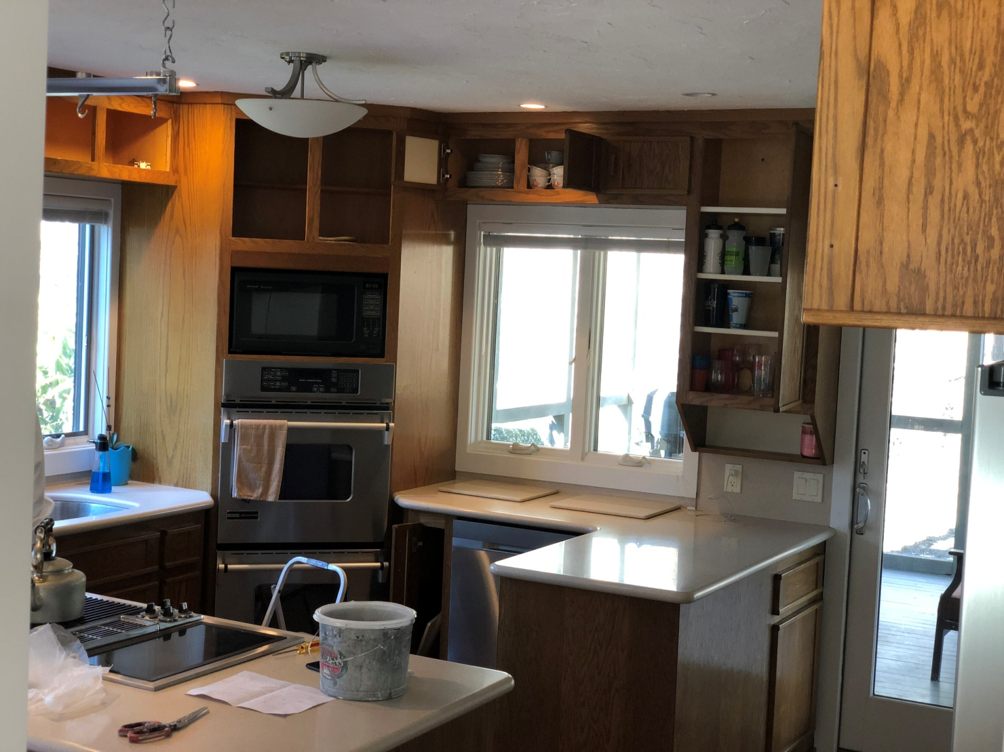

DON'T INCLUDE PAINTING INSIDE THE CABINET.
CABINETS:
COLOR SAME LIKE WITE DOORS 31Unit
STYLE OAK-WOOD FOR SMOOTH DRAWERS 11 Unit
COMPLETE JOB IN 3 WEEKS

We use only the highest quality materials.
” Thank you so much for trusting me . I do my best, taking care of your house as if it were mine. I take pleasure and love my job. “
Wellington B. Bovenschulte
Master Painter
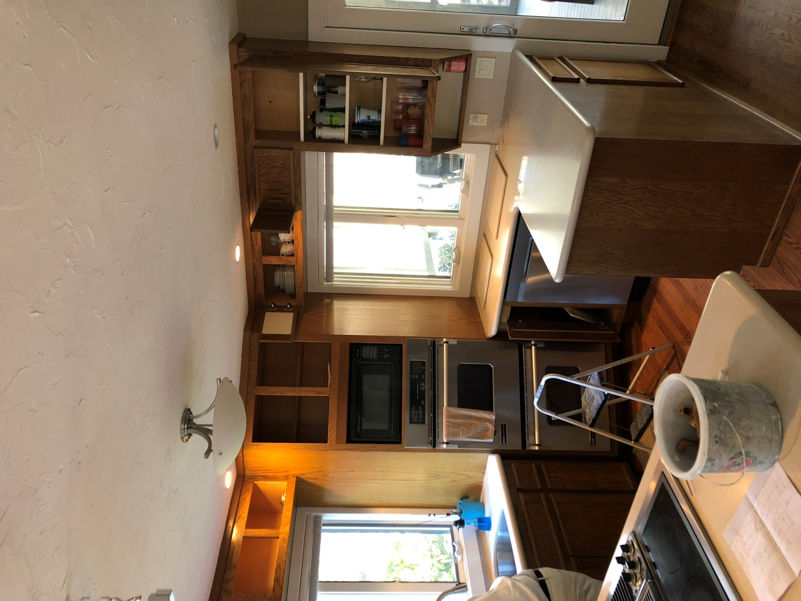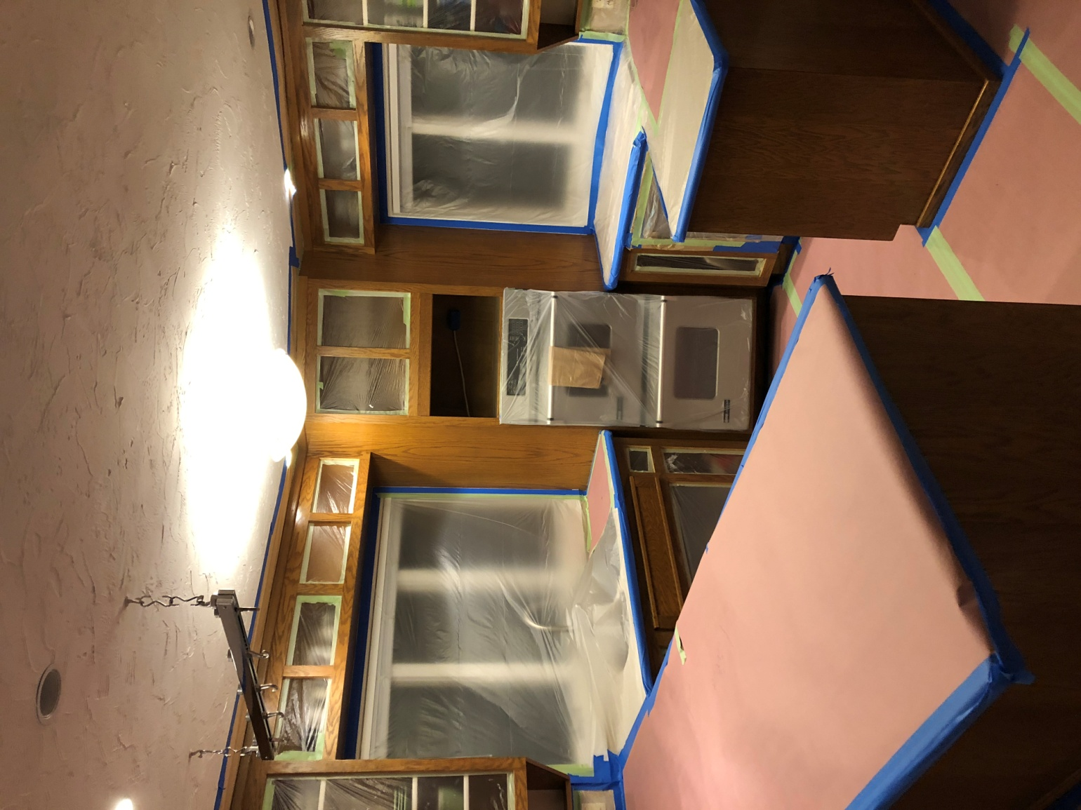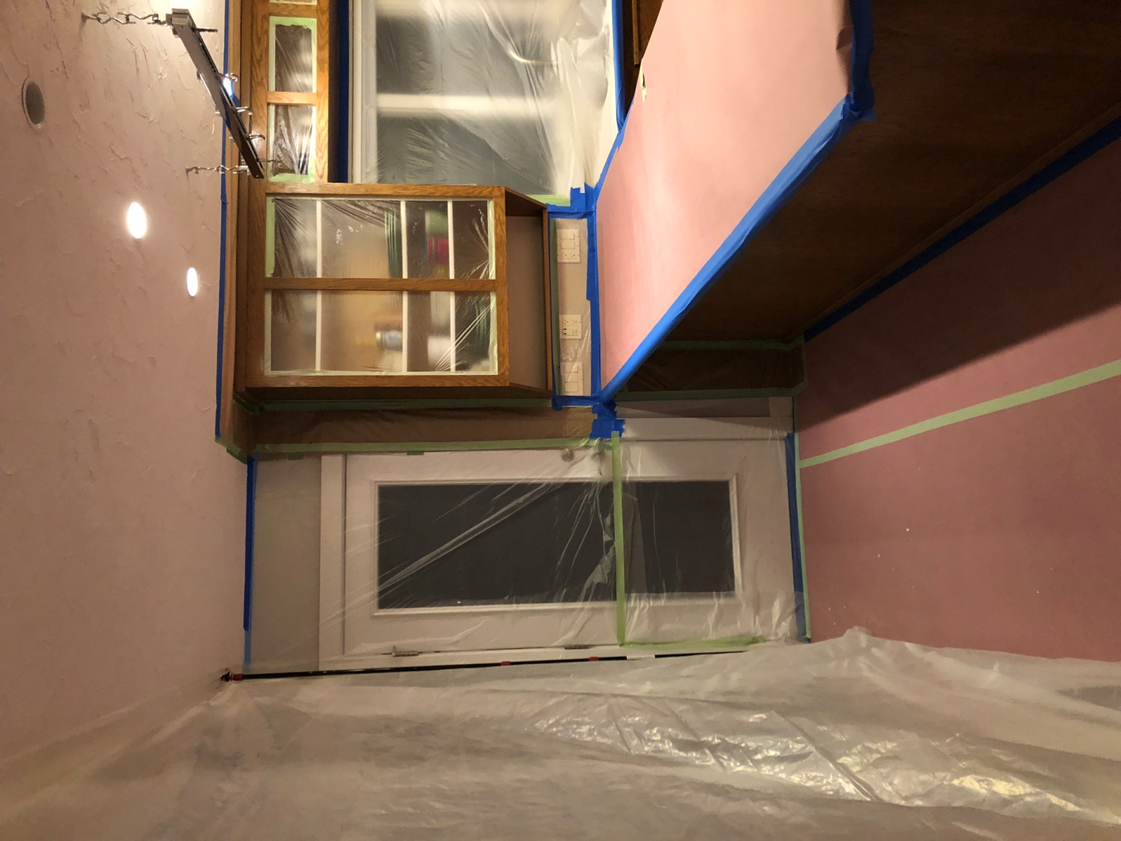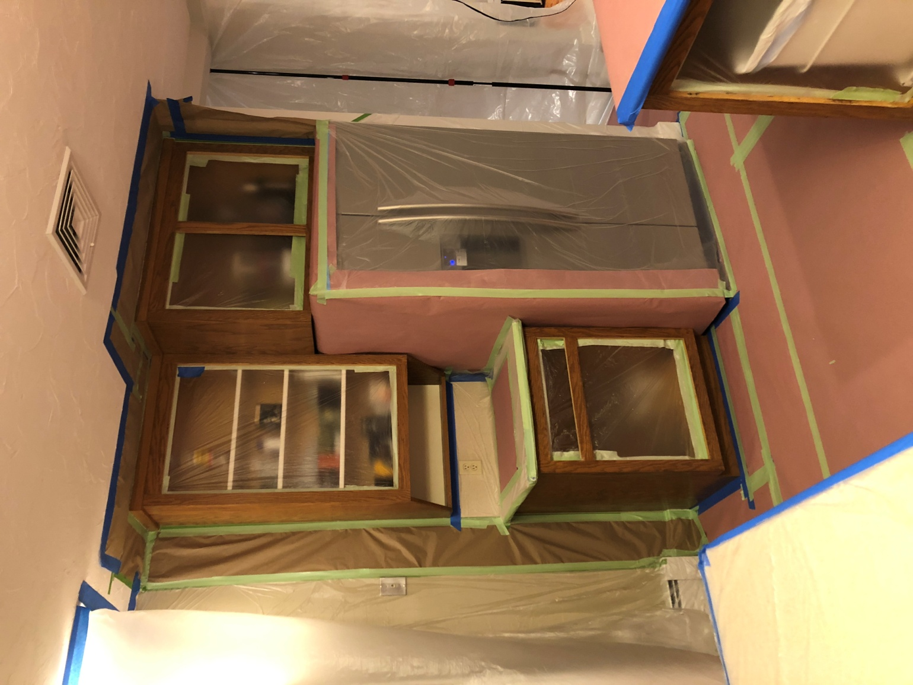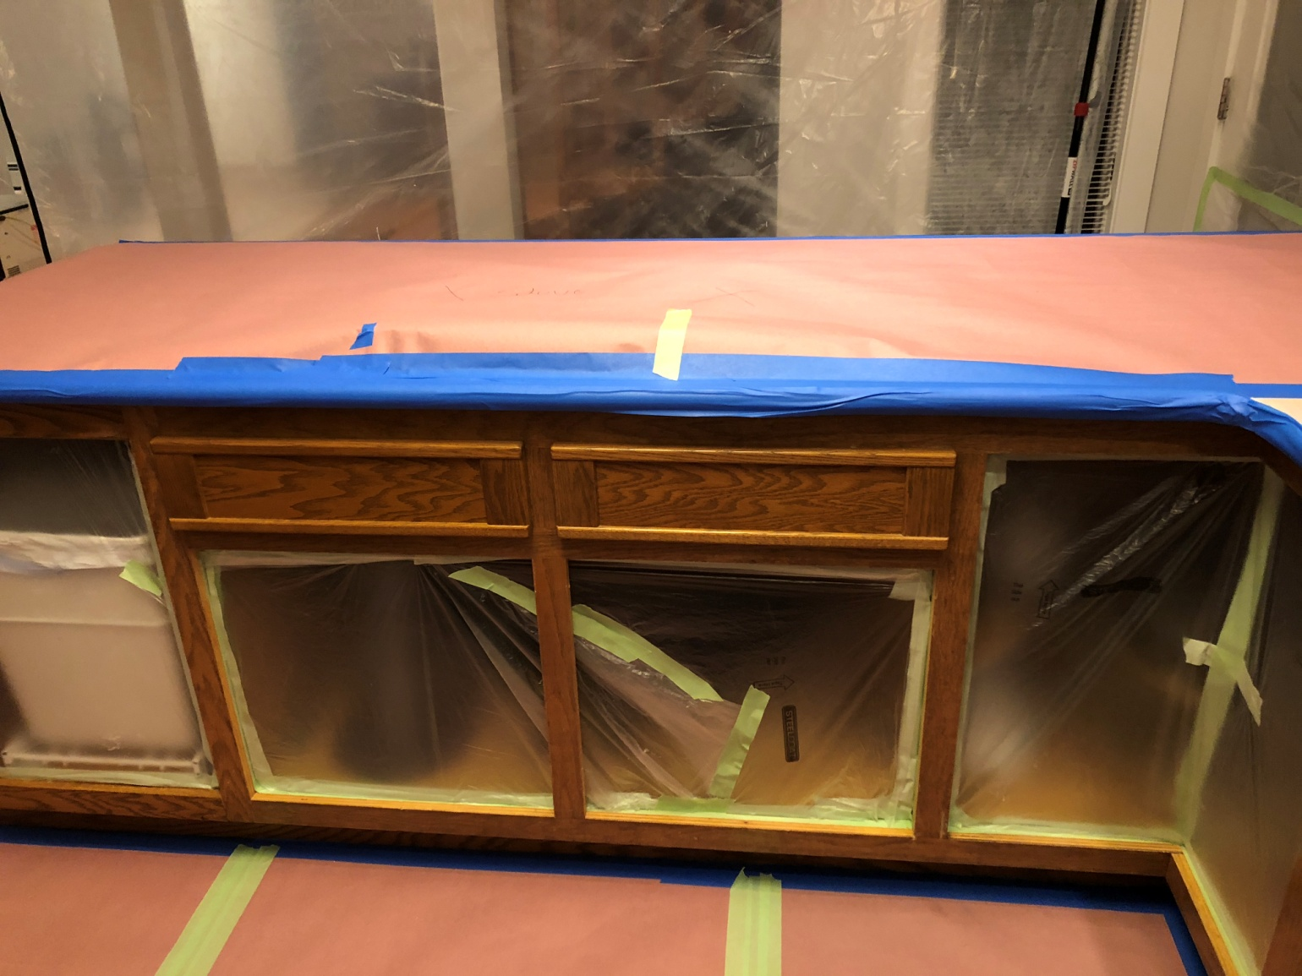

DON'T INCLUDE PAINTING INSIDE THE CABINET.
CABINETS:
COLOR SAME LIKE WITE DOORS 31Unit
STYLE OAK-WOOD FOR SMOOTH DRAWERS 11 Unit
COMPLETE JOB IN 3 WEEKS

We use only the highest quality materials.
” Thank you so much for trusting me . I do my best, taking care of your house as if it were mine. I take pleasure and love my job. “
Wellington B. Bovenschulte
Master Painter
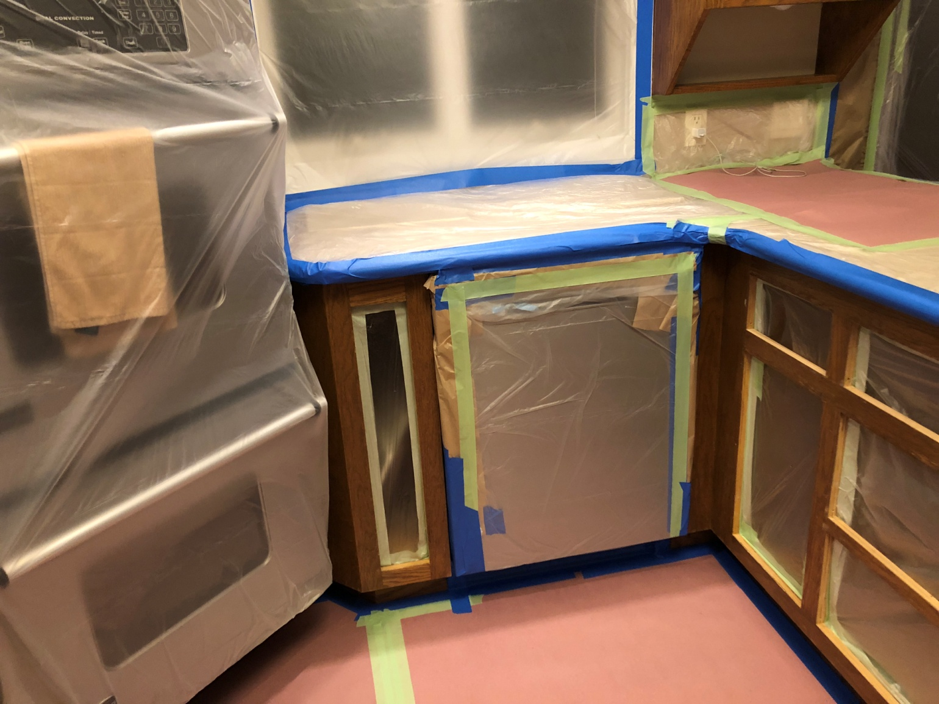

DON'T INCLUDE PAINTING INSIDE THE CABINET.
CABINETS:
COLOR SAME LIKE WITE DOORS 31Unit
STYLE OAK-WOOD FOR SMOOTH DRAWERS 11 Unit
COMPLETE JOB IN 3 WEEKS

We use only the highest quality materials.
” Thank you so much for trusting me . I do my best, taking care of your house as if it were mine. I take pleasure and love my job. “
Wellington B. Bovenschulte
Master Painter
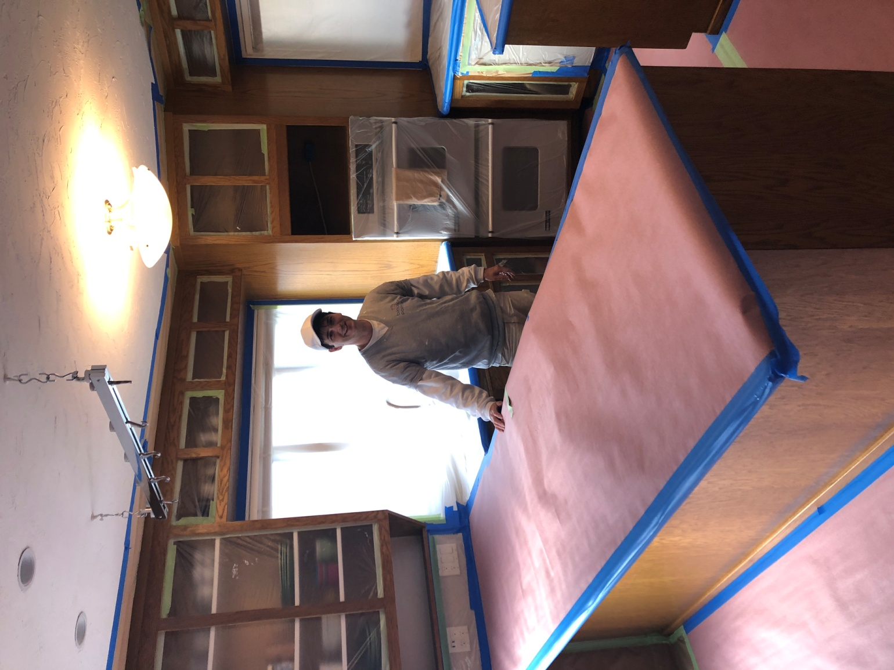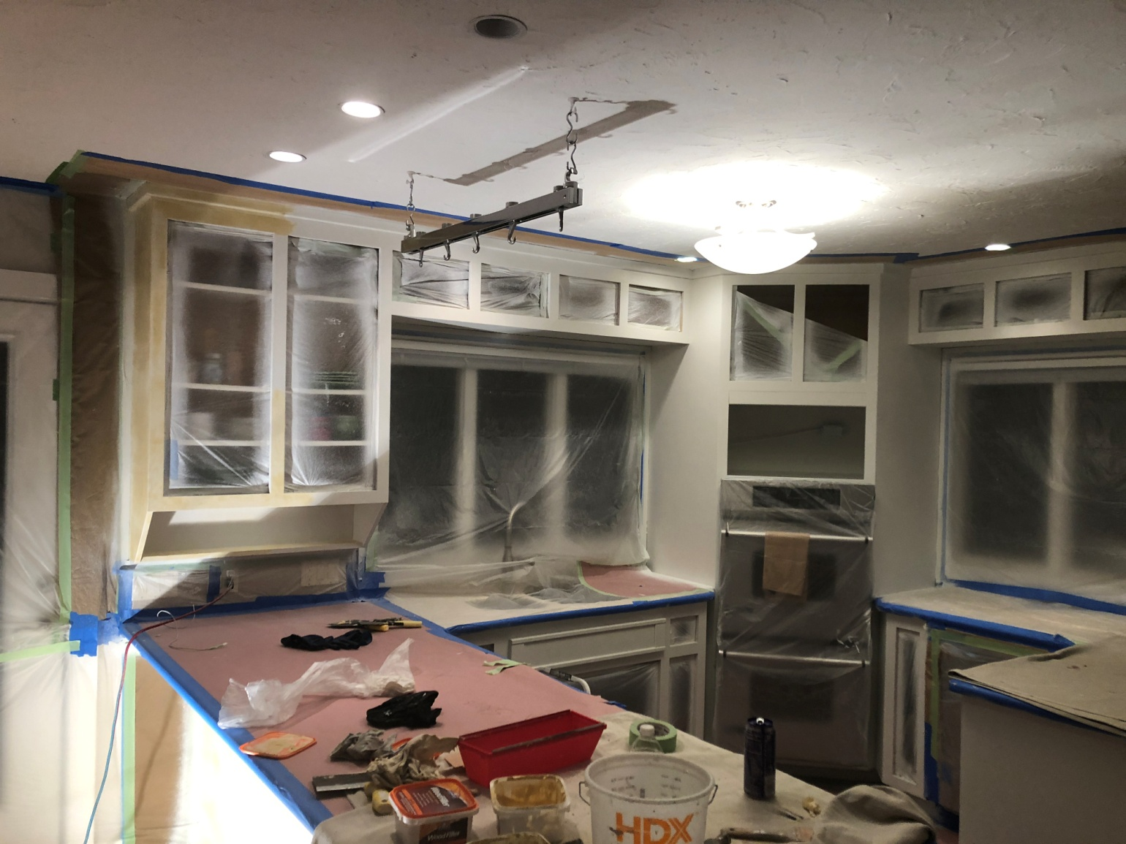

DON'T INCLUDE PAINTING INSIDE THE CABINET.
CABINETS:
COLOR SAME LIKE WITE DOORS 31Unit
STYLE OAK-WOOD FOR SMOOTH DRAWERS 11 Unit
COMPLETE JOB IN 3 WEEKS

We use only the highest quality materials.
” Thank you so much for trusting me . I do my best, taking care of your house as if it were mine. I take pleasure and love my job. “
Wellington B. Bovenschulte
Master Painter
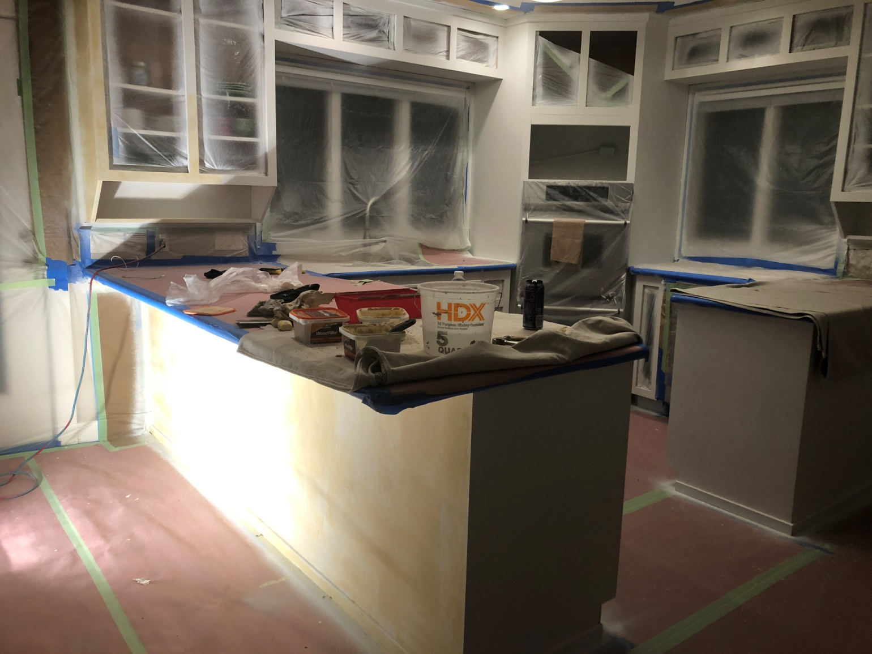

DON'T INCLUDE PAINTING INSIDE THE CABINET.
CABINETS:
COLOR SAME LIKE WITE DOORS 31Unit
STYLE OAK-WOOD FOR SMOOTH DRAWERS 11 Unit
COMPLETE JOB IN 3 WEEKS

We use only the highest quality materials.
” Thank you so much for trusting me . I do my best, taking care of your house as if it were mine. I take pleasure and love my job. “
Wellington B. Bovenschulte
Master Painter
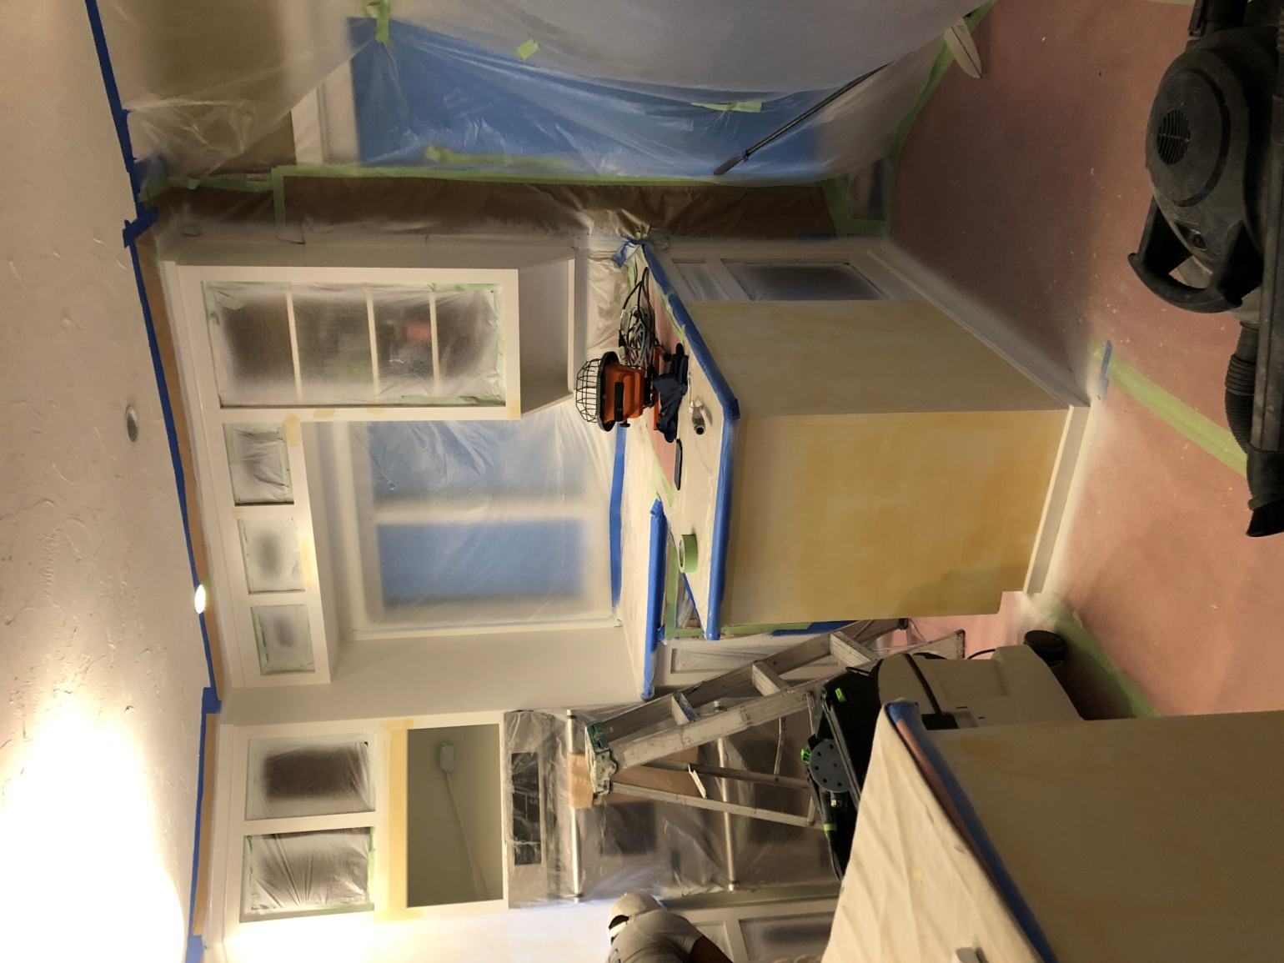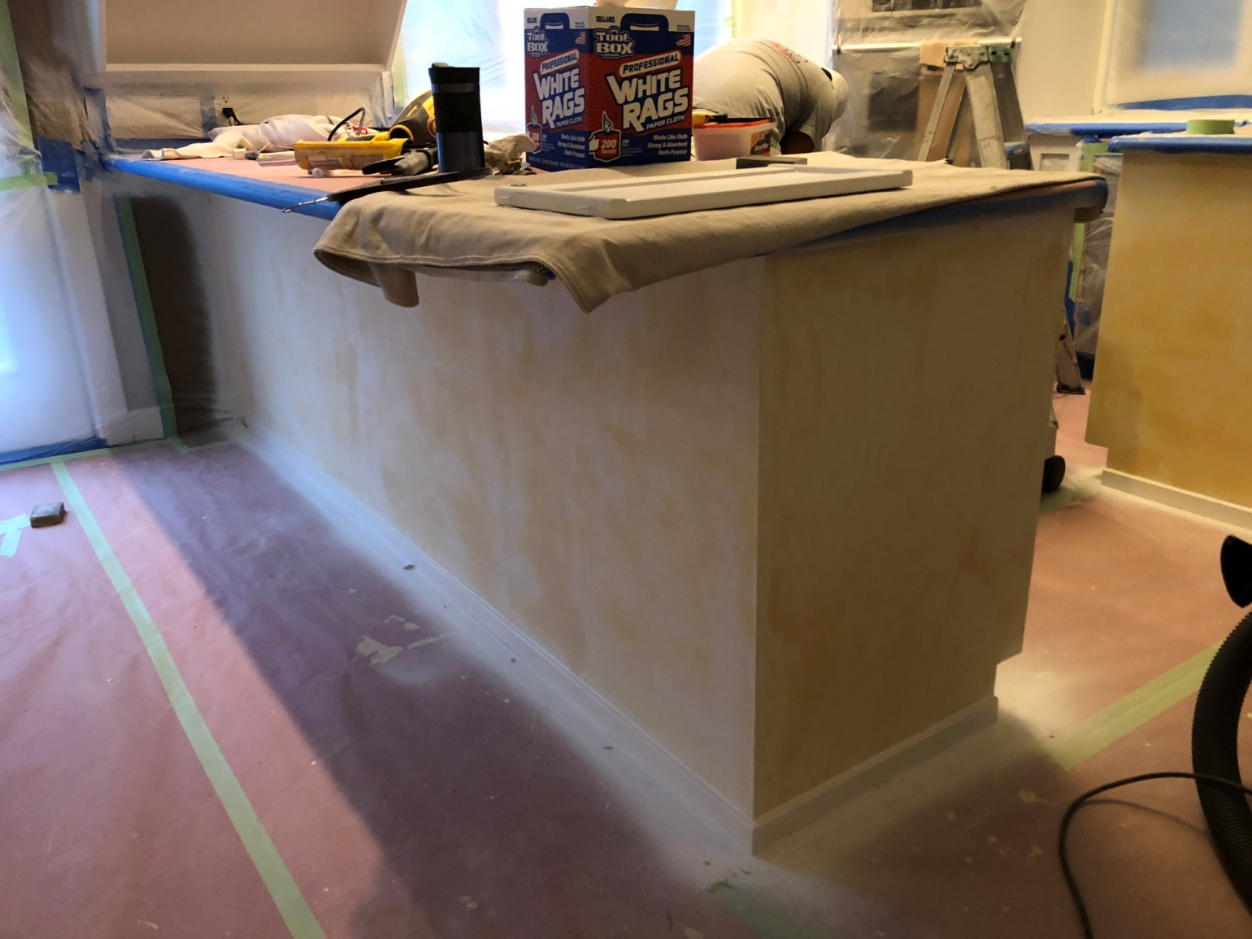

DON'T INCLUDE PAINTING INSIDE THE CABINET.
CABINETS:
COLOR SAME LIKE WITE DOORS 31Unit
STYLE OAK-WOOD FOR SMOOTH DRAWERS 11 Unit
COMPLETE JOB IN 3 WEEKS

We use only the highest quality materials.
” Thank you so much for trusting me . I do my best, taking care of your house as if it were mine. I take pleasure and love my job. “
Wellington B. Bovenschulte
Master Painter
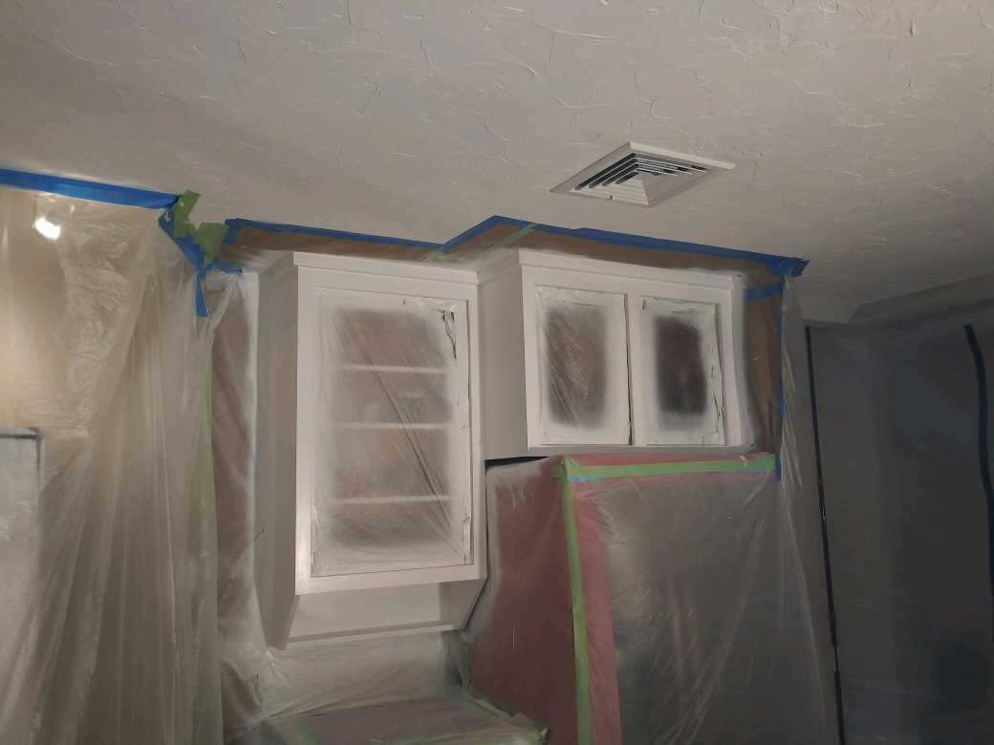

DON'T INCLUDE PAINTING INSIDE THE CABINET.
CABINETS:
COLOR SAME LIKE WITE DOORS 31Unit
STYLE OAK-WOOD FOR SMOOTH DRAWERS 11 Unit
COMPLETE JOB IN 3 WEEKS

We use only the highest quality materials.
” Thank you so much for trusting me . I do my best, taking care of your house as if it were mine. I take pleasure and love my job. “
Wellington B. Bovenschulte
Master Painter
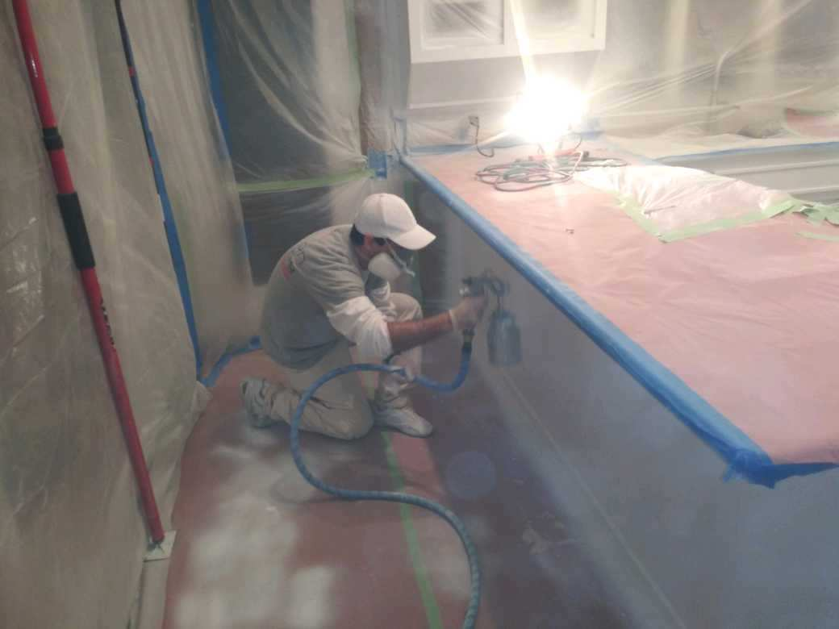
DON'T INCLUDE PAINTING INSIDE THE CABINET.
CABINETS:
COLOR SAME LIKE WITE DOORS 31Unit
STYLE OAK-WOOD FOR SMOOTH DRAWERS 11 Unit
COMPLETE JOB IN 3 WEEKS

We use only the highest quality materials.
” Thank you so much for trusting me . I do my best, taking care of your house as if it were mine. I take pleasure and love my job. “
Wellington B. Bovenschulte
Master Painter
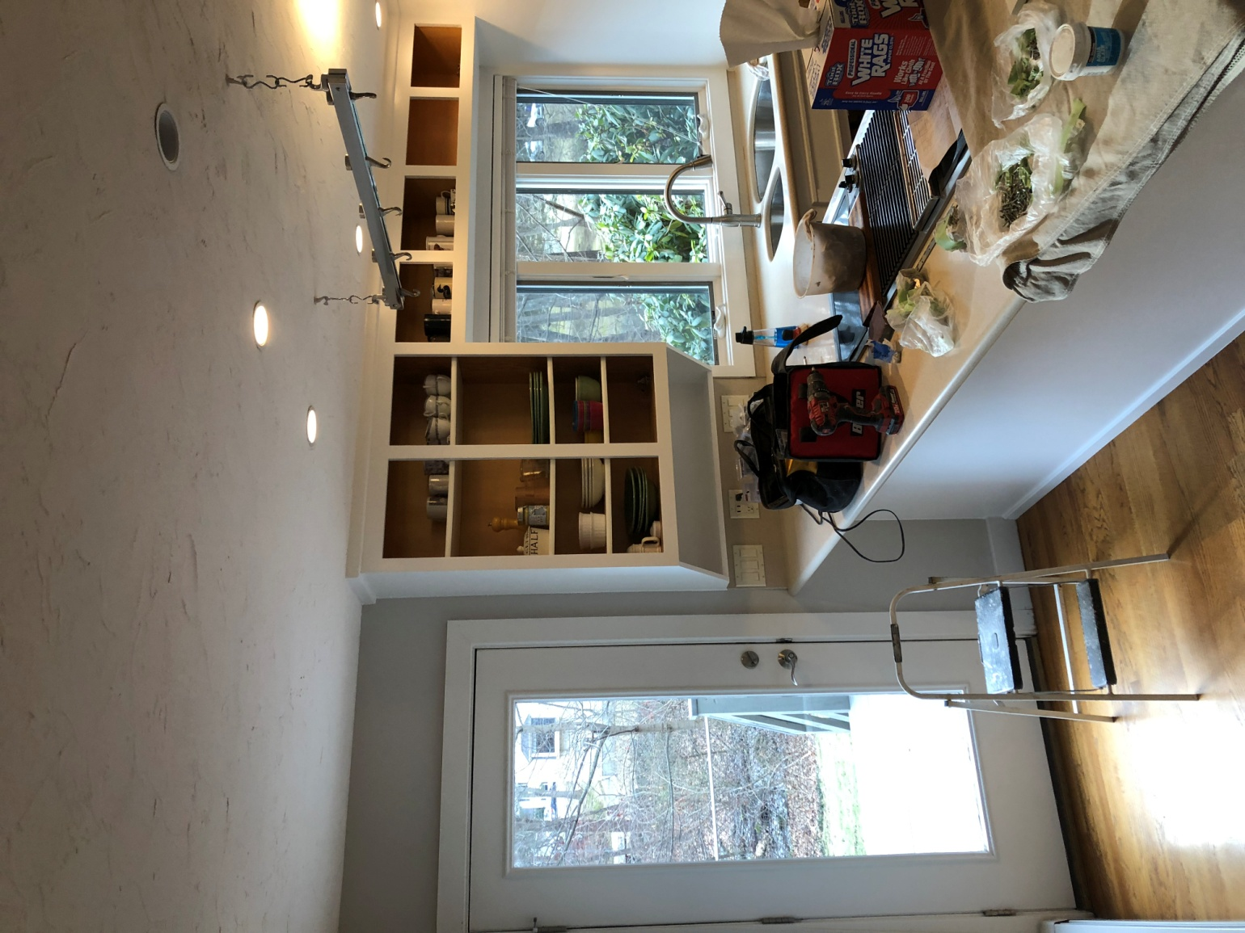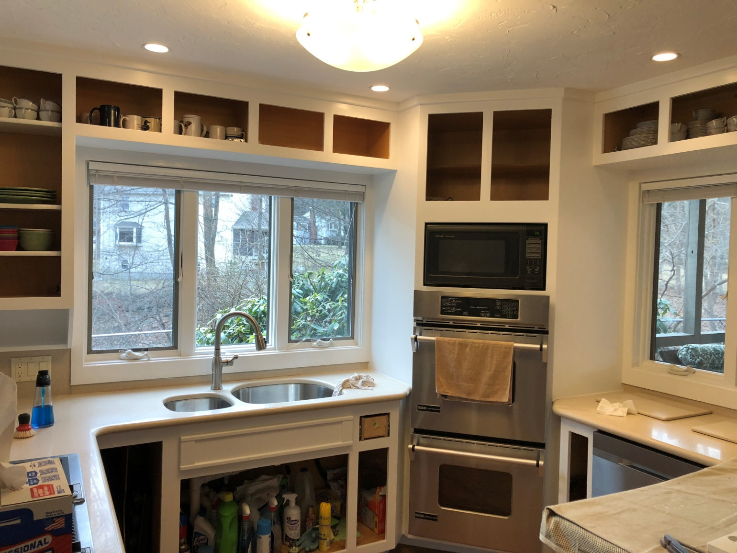

DON'T INCLUDE PAINTING INSIDE THE CABINET.
CABINETS:
COLOR SAME LIKE WITE DOORS 31Unit
STYLE OAK-WOOD FOR SMOOTH DRAWERS 11 Unit
COMPLETE JOB IN 3 WEEKS

We use only the highest quality materials.
” Thank you so much for trusting me . I do my best, taking care of your house as if it were mine. I take pleasure and love my job. “
Wellington B. Bovenschulte
Master Painter
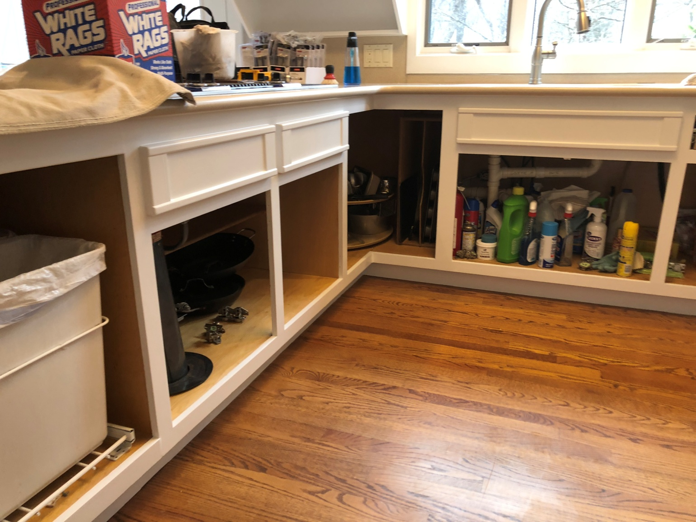

DON'T INCLUDE PAINTING INSIDE THE CABINET.
CABINETS:
COLOR SAME LIKE WITE DOORS 31Unit
STYLE OAK-WOOD FOR SMOOTH DRAWERS 11 Unit
COMPLETE JOB IN 3 WEEKS

We use only the highest quality materials.
” Thank you so much for trusting me . I do my best, taking care of your house as if it were mine. I take pleasure and love my job. “
Wellington B. Bovenschulte
Master Painter
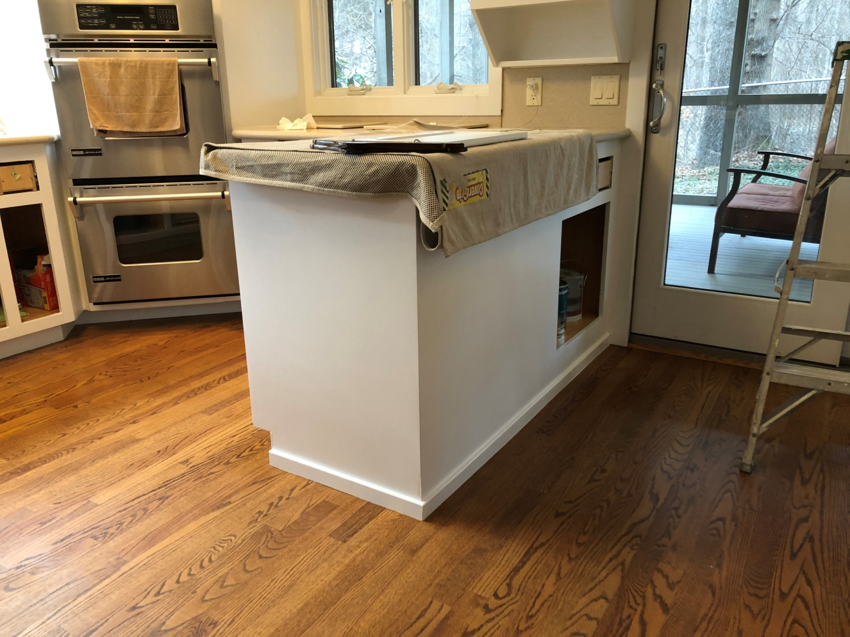

DON'T INCLUDE PAINTING INSIDE THE CABINET.
CABINETS:
COLOR SAME LIKE WITE DOORS 31Unit
STYLE OAK-WOOD FOR SMOOTH DRAWERS 11 Unit
COMPLETE JOB IN 3 WEEKS

We use only the highest quality materials.
” Thank you so much for trusting me . I do my best, taking care of your house as if it were mine. I take pleasure and love my job. “
Wellington B. Bovenschulte
Master Painter
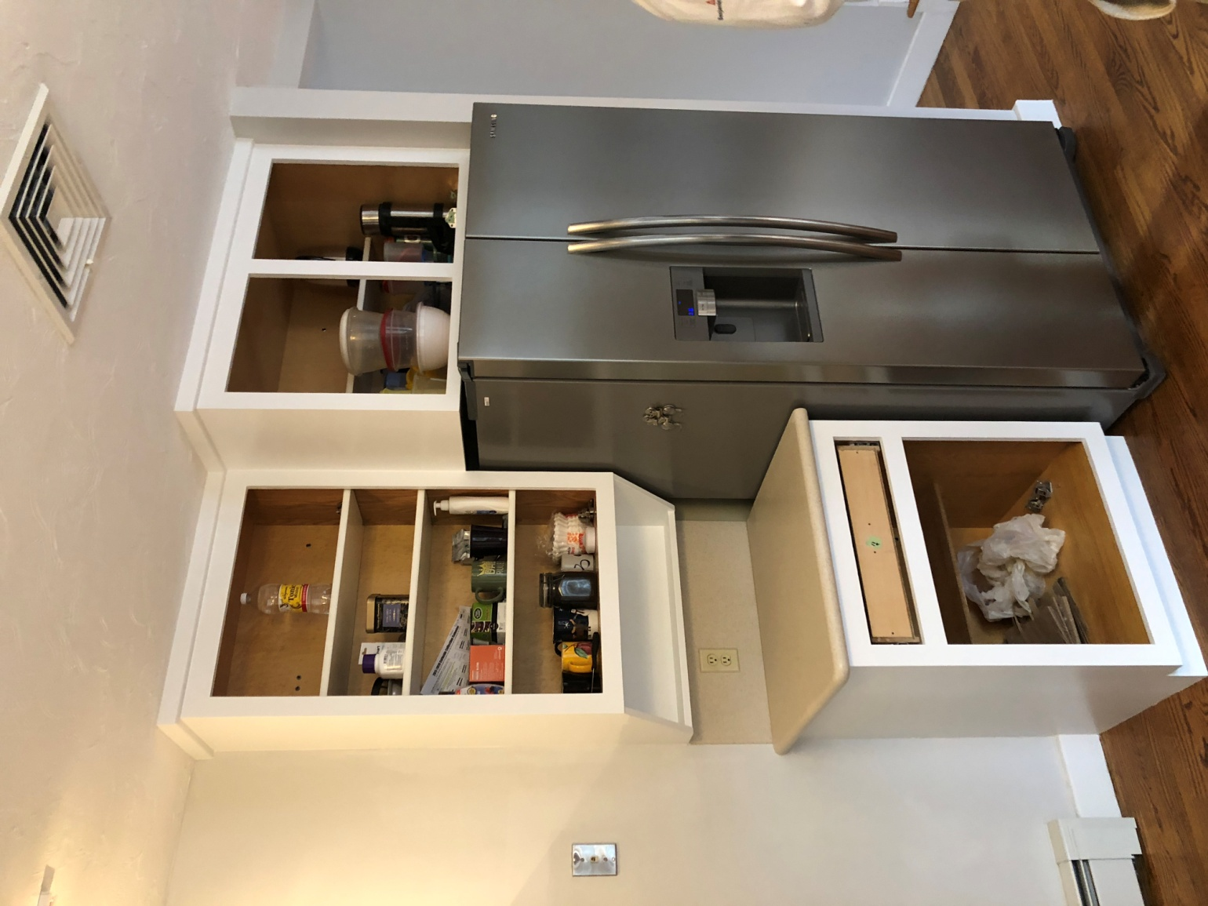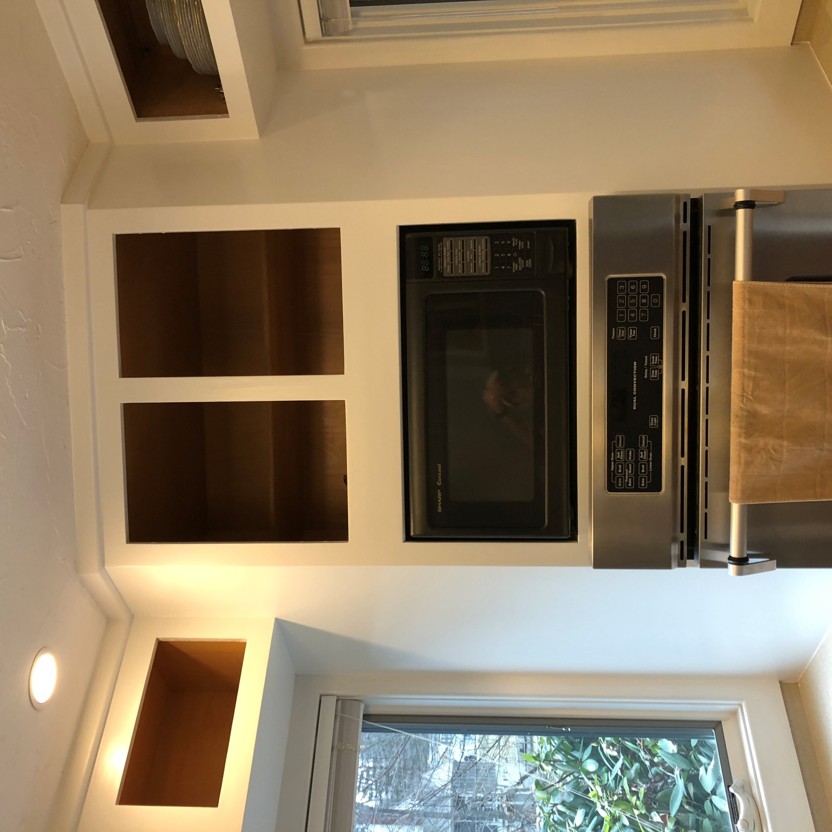

DON'T INCLUDE PAINTING INSIDE THE CABINET.
CABINETS:
COLOR SAME LIKE WITE DOORS 31Unit
STYLE OAK-WOOD FOR SMOOTH DRAWERS 11 Unit
COMPLETE JOB IN 3 WEEKS
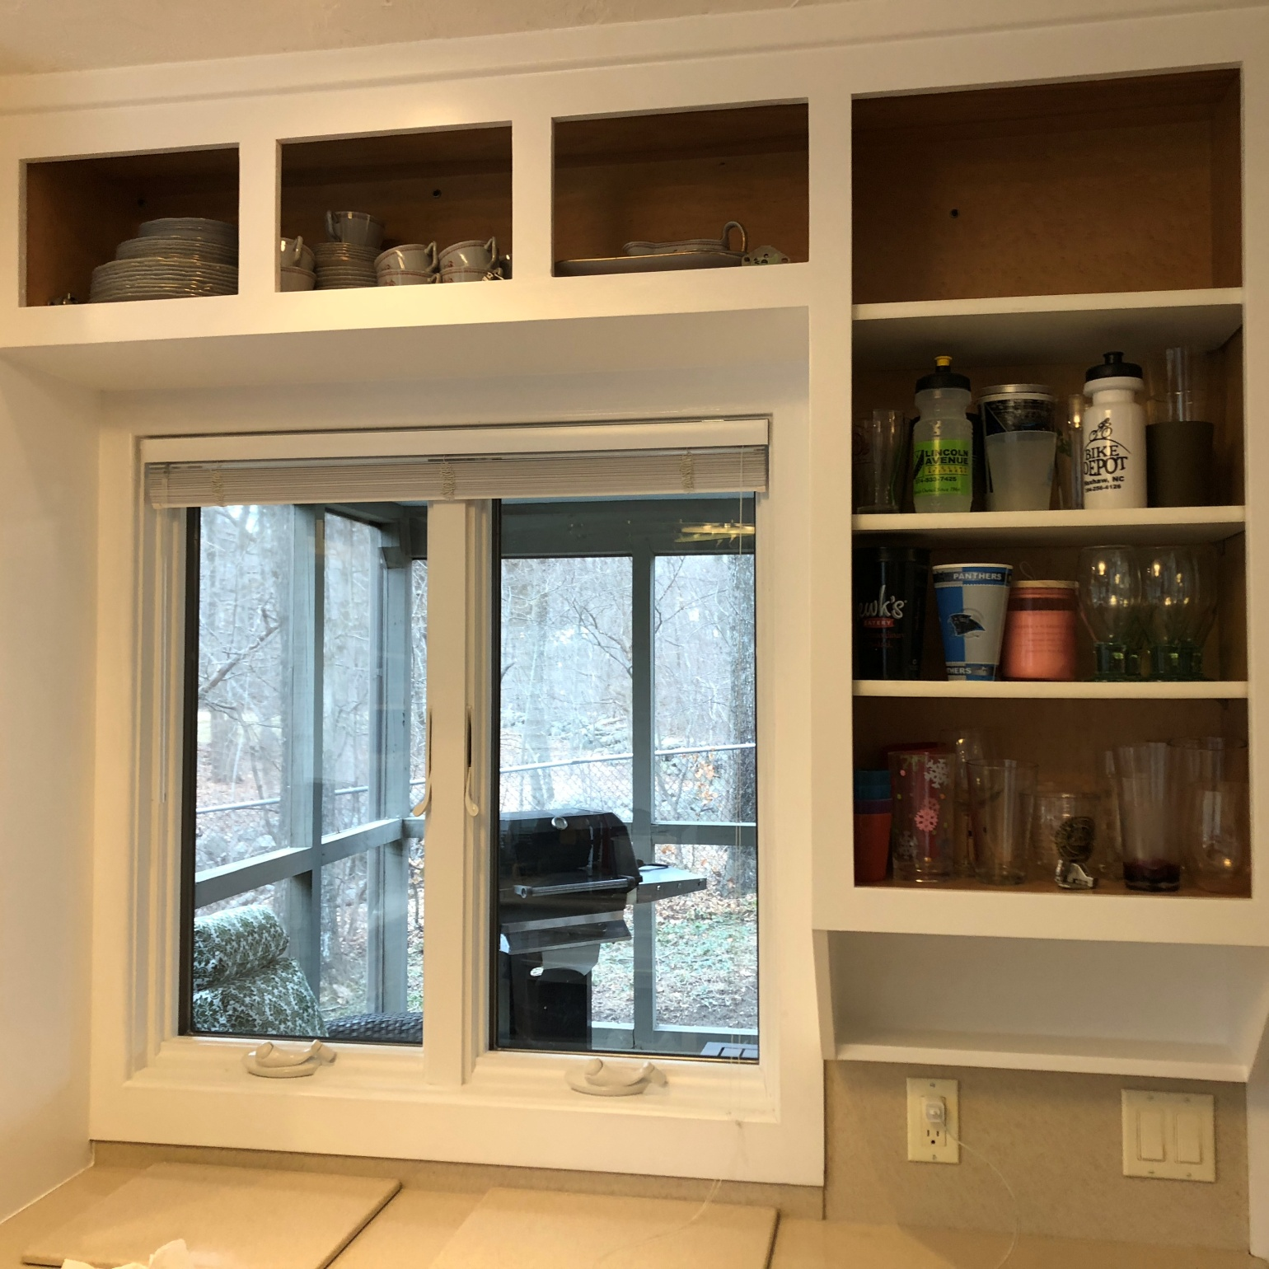

DON'T INCLUDE PAINTING INSIDE THE CABINET.
CABINETS:
COLOR SAME LIKE WITE DOORS 31Unit
STYLE OAK-WOOD FOR SMOOTH DRAWERS 11 Unit
COMPLETE JOB IN 3 WEEKS
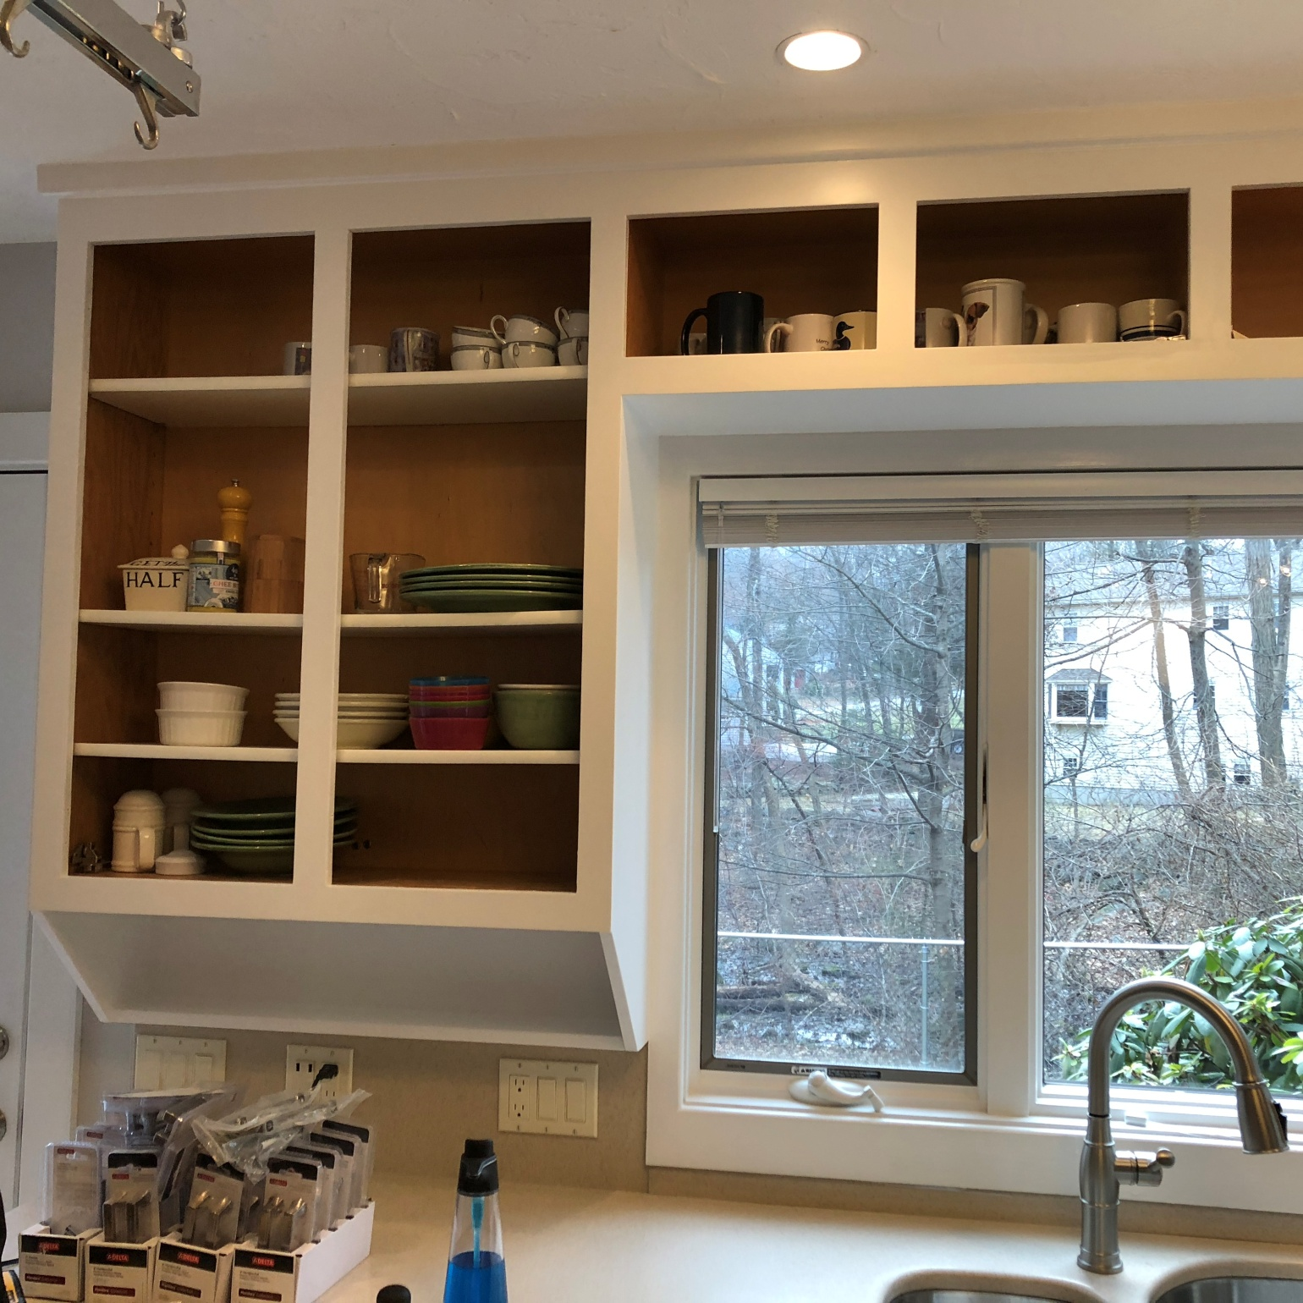

DON'T INCLUDE PAINTING INSIDE THE CABINET.
CABINETS:
COLOR SAME LIKE WITE DOORS 31Unit
STYLE OAK-WOOD FOR SMOOTH DRAWERS 11 Unit
COMPLETE JOB IN 3 WEEKS
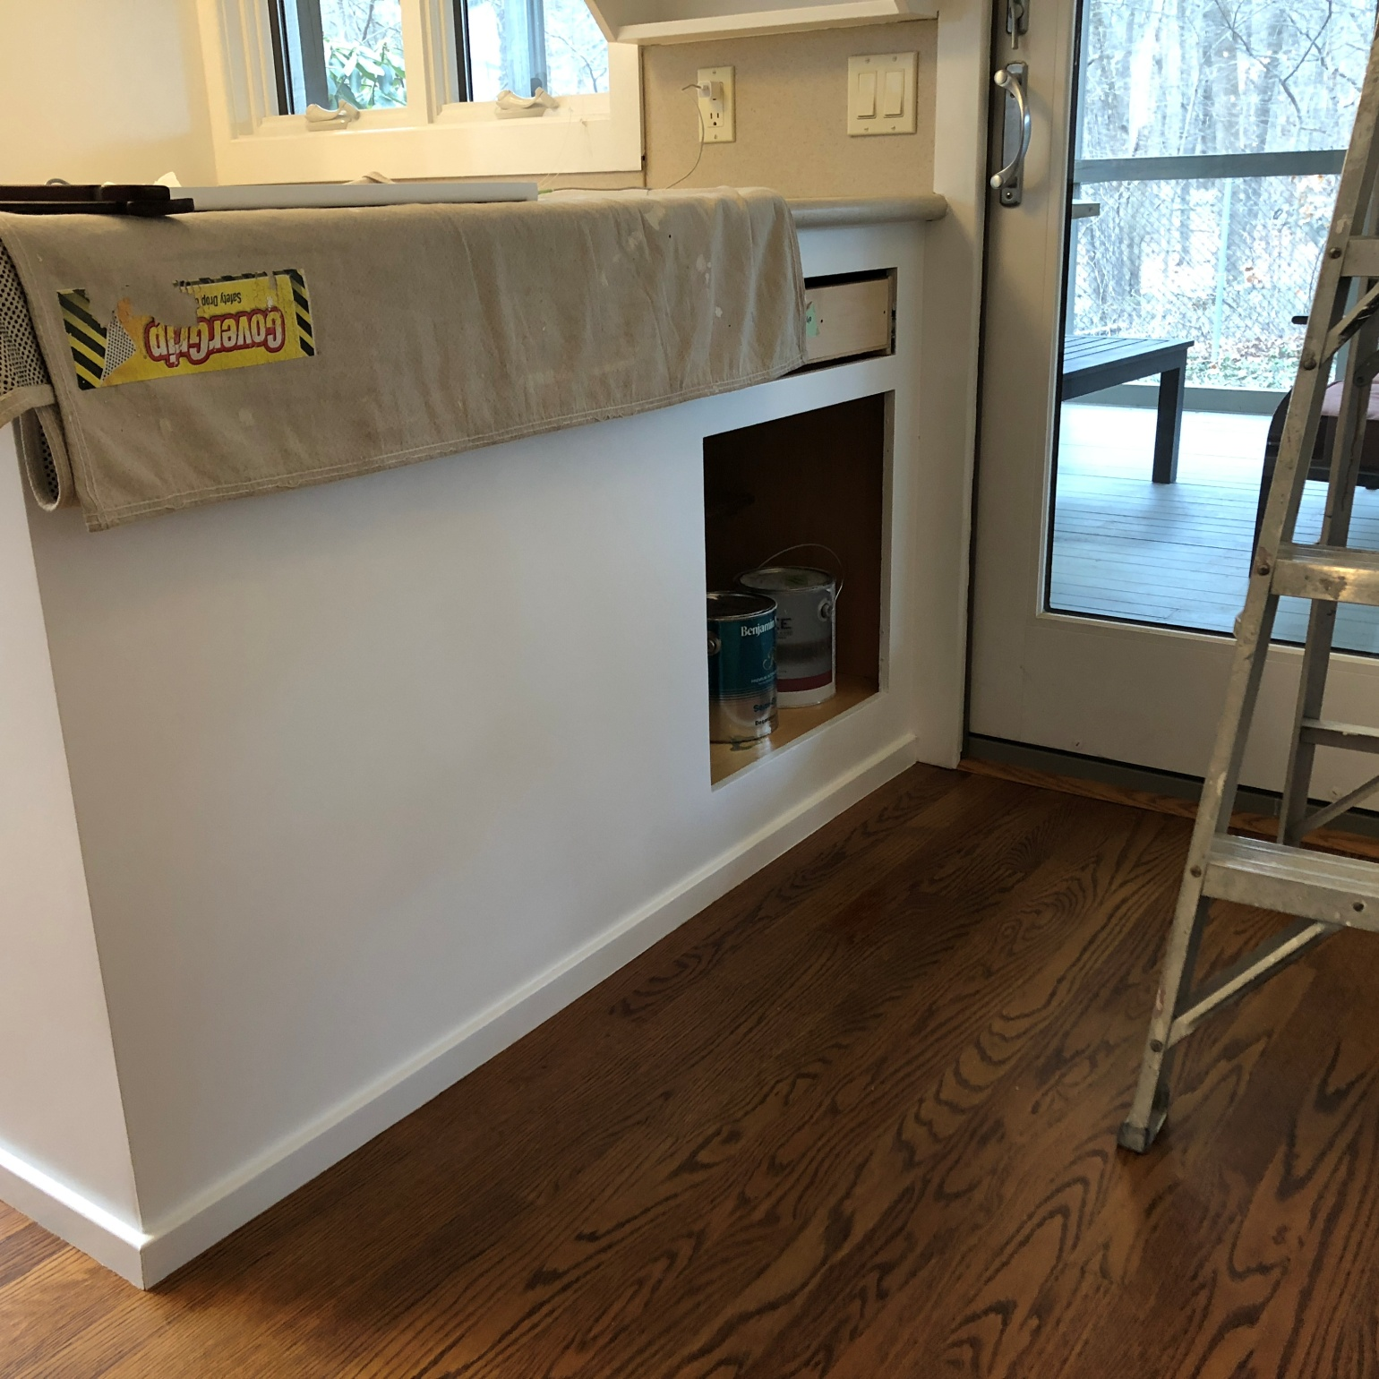

DON'T INCLUDE PAINTING INSIDE THE CABINET.
CABINETS:
COLOR SAME LIKE WITE DOORS 31Unit
STYLE OAK-WOOD FOR SMOOTH DRAWERS 11 Unit
COMPLETE JOB IN 3 WEEKS
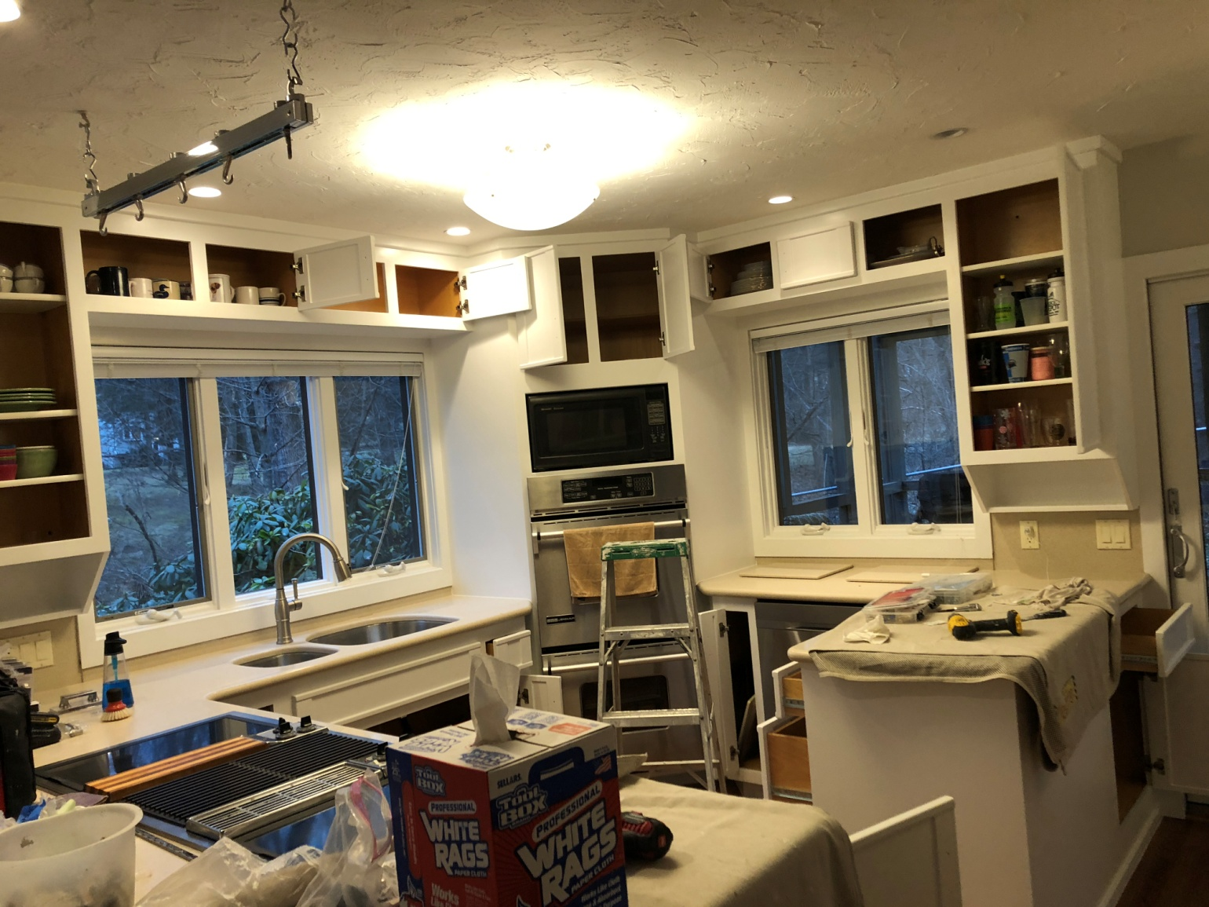

DON'T INCLUDE PAINTING INSIDE THE CABINET.
CABINETS:
COLOR SAME LIKE WITE DOORS 31Unit
STYLE OAK-WOOD FOR SMOOTH DRAWERS 11 Unit
COMPLETE JOB IN 3 WEEKS

We use only the highest quality materials.
” Thank you so much for trusting me . I do my best, taking care of your house as if it were mine. I take pleasure and love my job. “
Wellington B. Bovenschulte
Master Painter
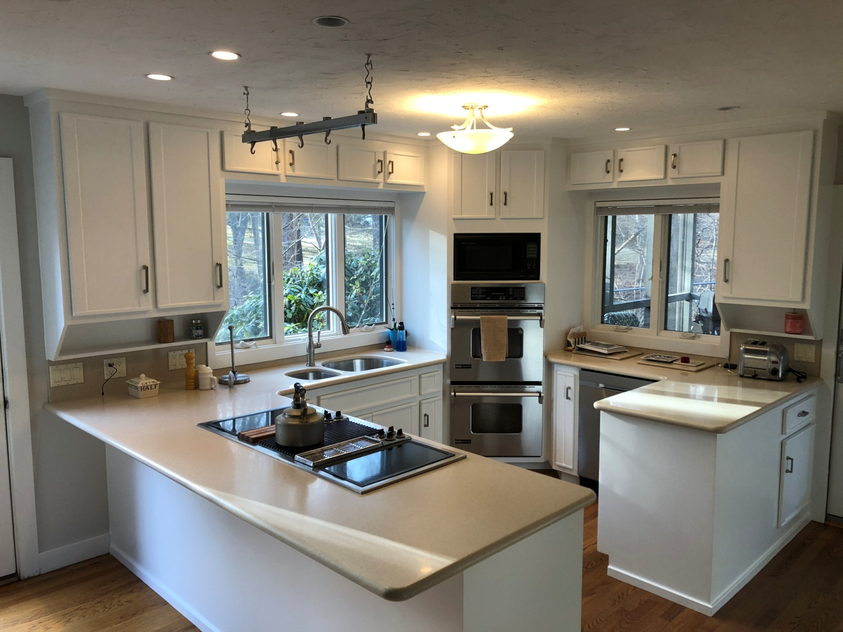

DON'T INCLUDE PAINTING INSIDE THE CABINET.
CABINETS:
COLOR SAME LIKE WITE DOORS 31Unit
STYLE OAK-WOOD FOR SMOOTH DRAWERS 11 Unit
COMPLETE JOB IN 3 WEEKS

We use only the highest quality materials.
” Thank you so much for trusting me . I do my best, taking care of your house as if it were mine. I take pleasure and love my job. “
Wellington B. Bovenschulte
Master Painter
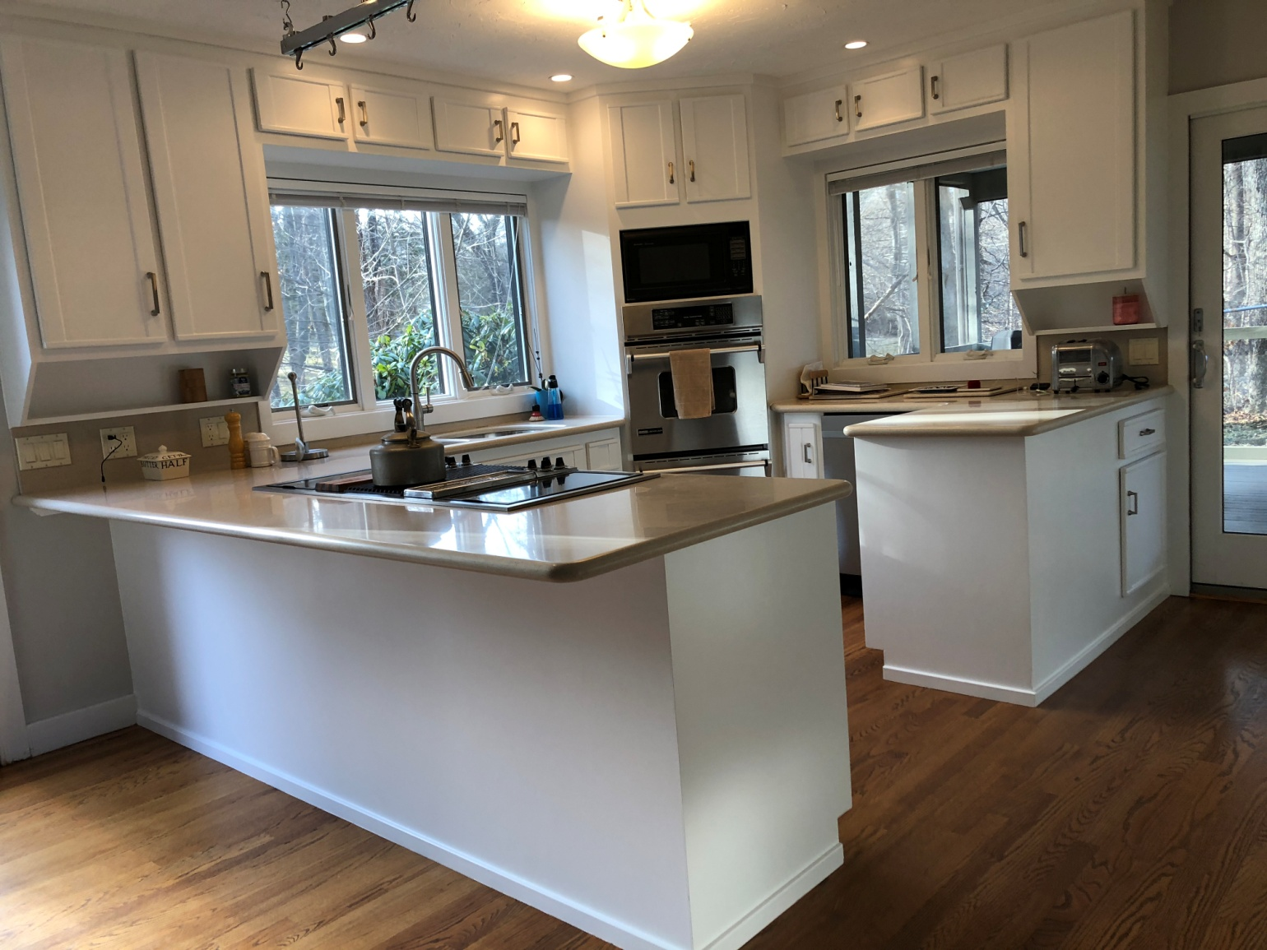

DON'T INCLUDE PAINTING INSIDE THE CABINET.
CABINETS:
COLOR SAME LIKE WITE DOORS 31Unit
STYLE OAK-WOOD FOR SMOOTH DRAWERS 11 Unit
COMPLETE JOB IN 3 WEEKS

We use only the highest quality materials.
” Thank you so much for trusting me . I do my best, taking care of your house as if it were mine. I take pleasure and love my job. “
Wellington B. Bovenschulte
Master Painter
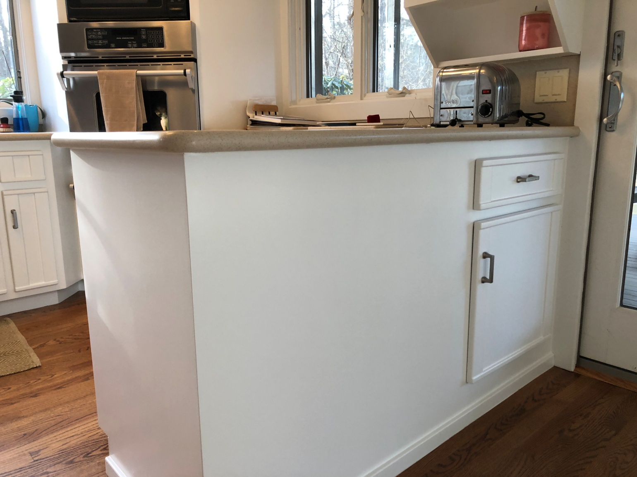

DON'T INCLUDE PAINTING INSIDE THE CABINET.
CABINETS:
COLOR SAME LIKE WITE DOORS 31Unit
STYLE OAK-WOOD FOR SMOOTH DRAWERS 11 Unit
COMPLETE JOB IN 3 WEEKS

We use only the highest quality materials.
” Thank you so much for trusting me . I do my best, taking care of your house as if it were mine. I take pleasure and love my job. “
Wellington B. Bovenschulte
Master Painter
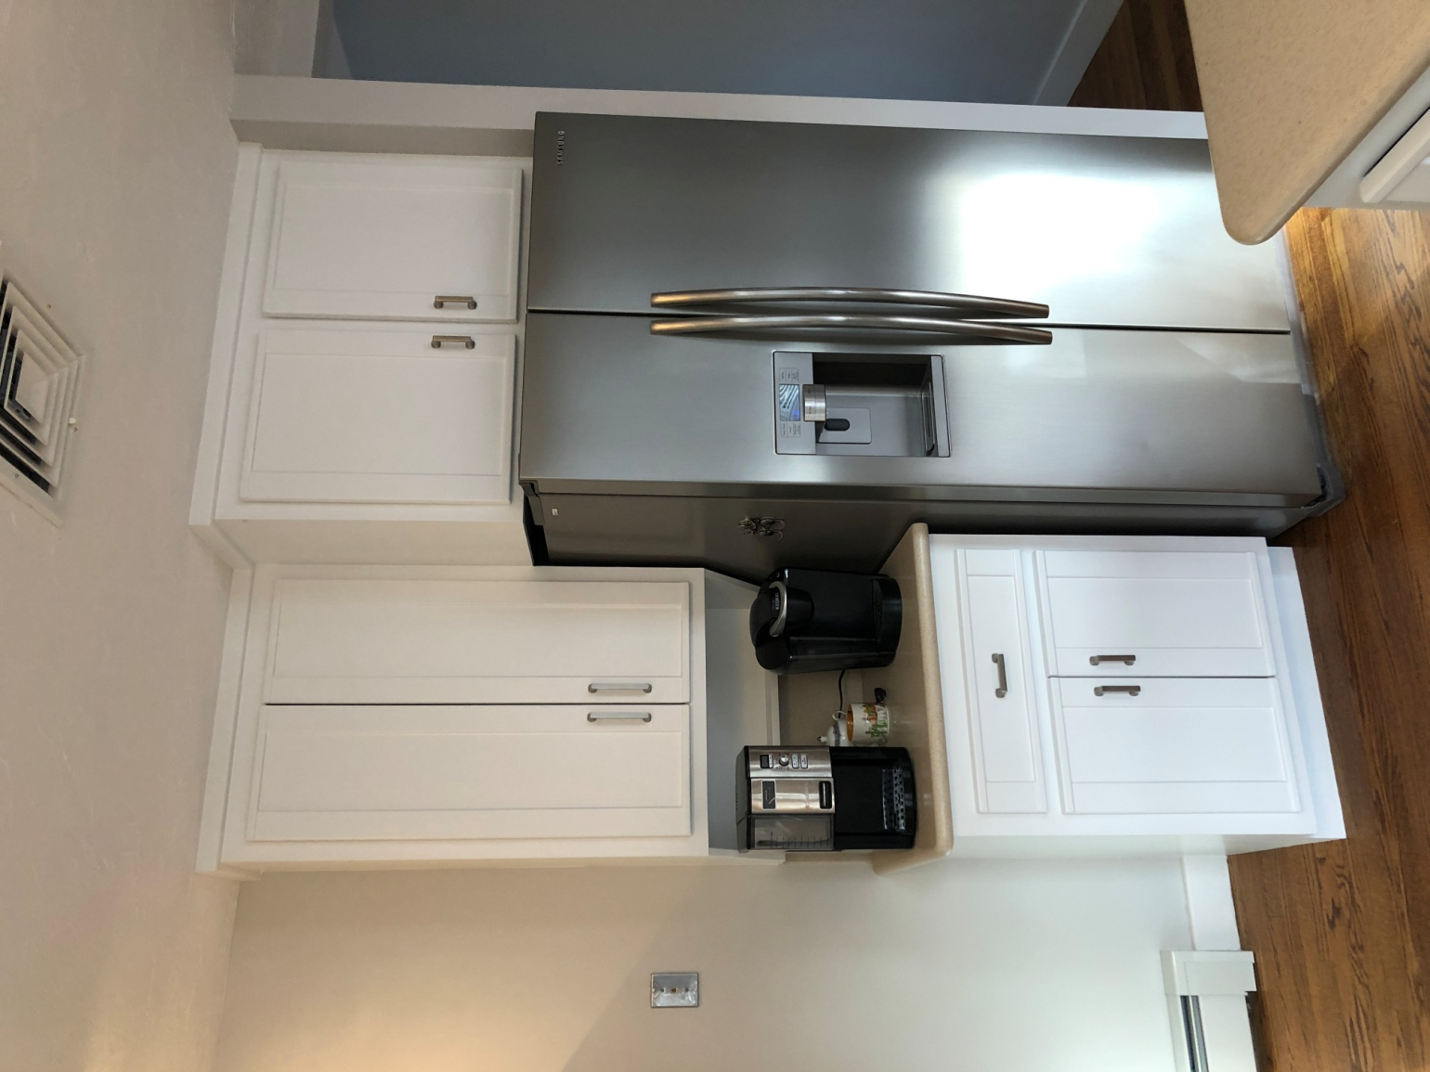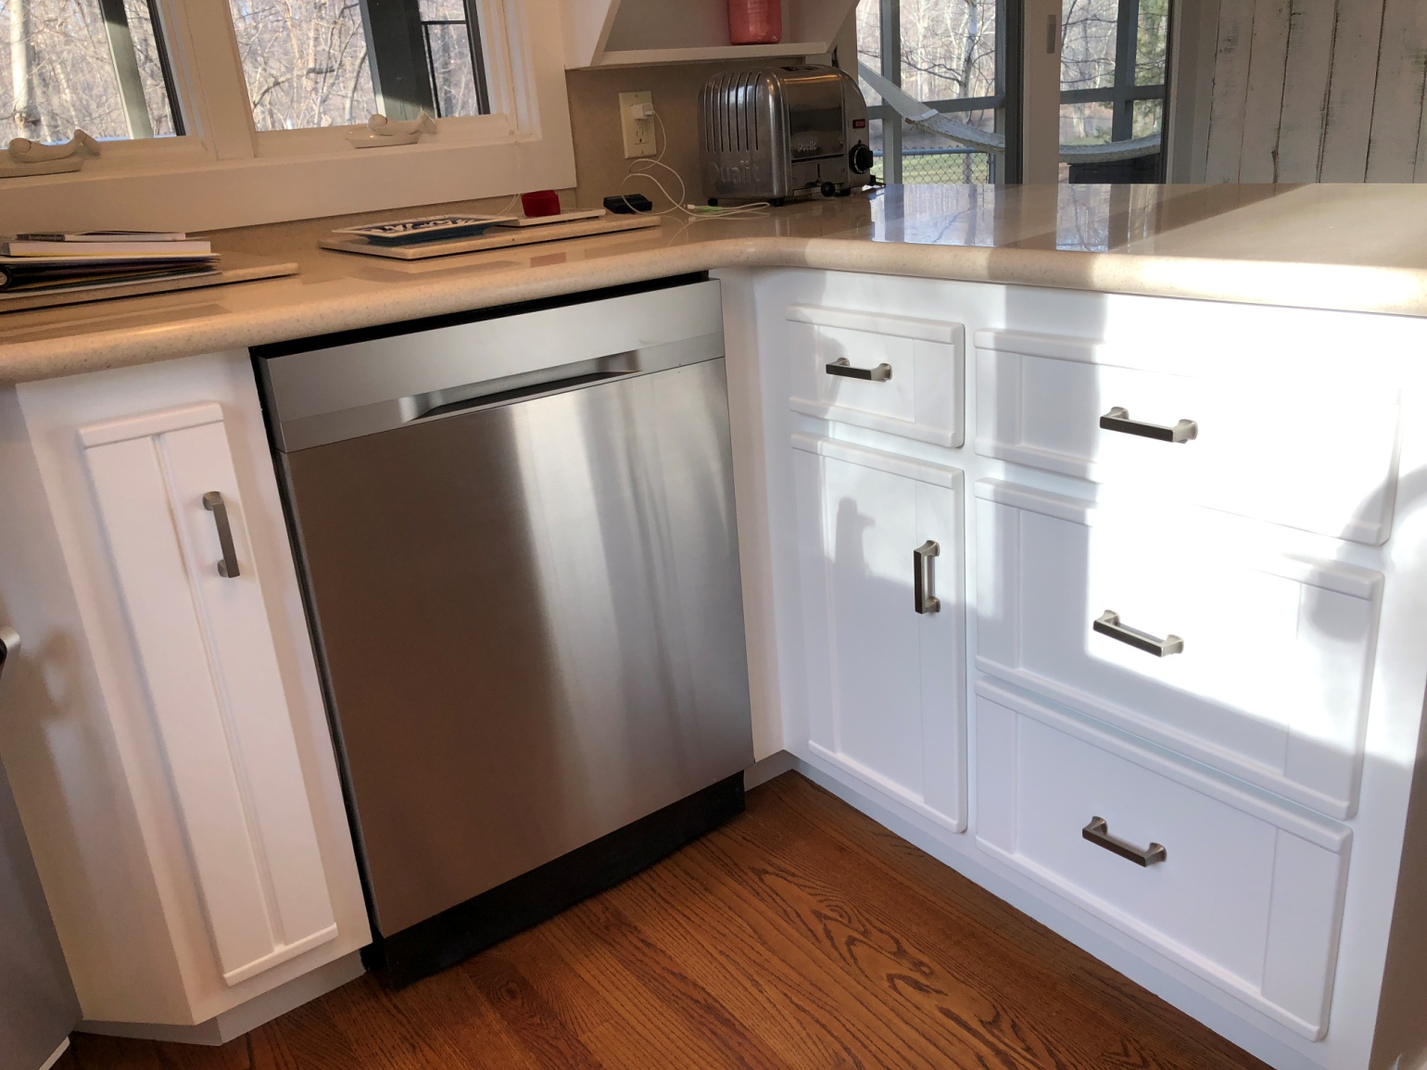

DON'T INCLUDE PAINTING INSIDE THE CABINET.
CABINETS:
COLOR SAME LIKE WITE DOORS 31Unit
STYLE OAK-WOOD FOR SMOOTH DRAWERS 11 Unit
COMPLETE JOB IN 3 WEEKS

We use only the highest quality materials.
” Thank you so much for trusting me . I do my best, taking care of your house as if it were mine. I take pleasure and love my job. “
Wellington B. Bovenschulte
Master Painter
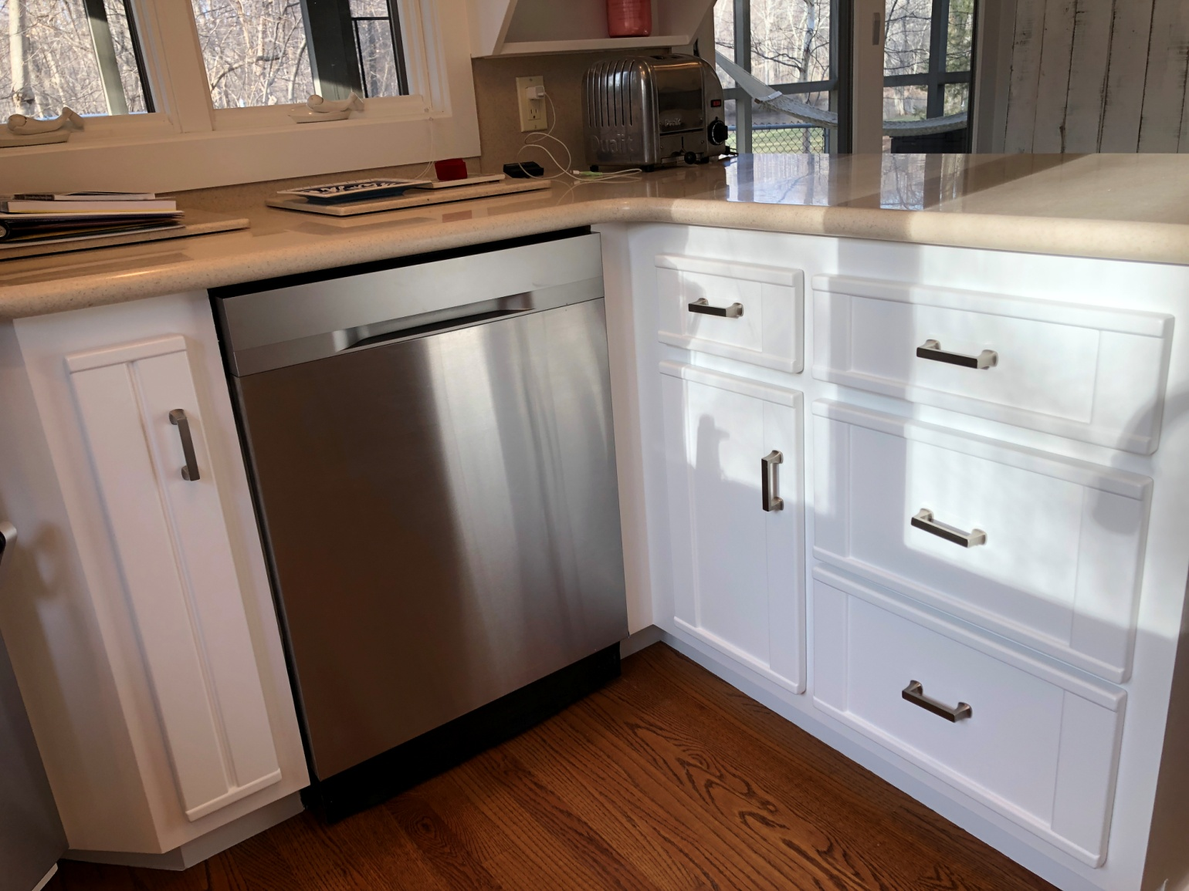

DON'T INCLUDE PAINTING INSIDE THE CABINET.
CABINETS:
COLOR SAME LIKE WITE DOORS 31Unit
STYLE OAK-WOOD FOR SMOOTH DRAWERS 11 Unit
COMPLETE JOB IN 3 WEEKS

We use only the highest quality materials.
” Thank you so much for trusting me . I do my best, taking care of your house as if it were mine. I take pleasure and love my job. “
Wellington B. Bovenschulte
Master Painter
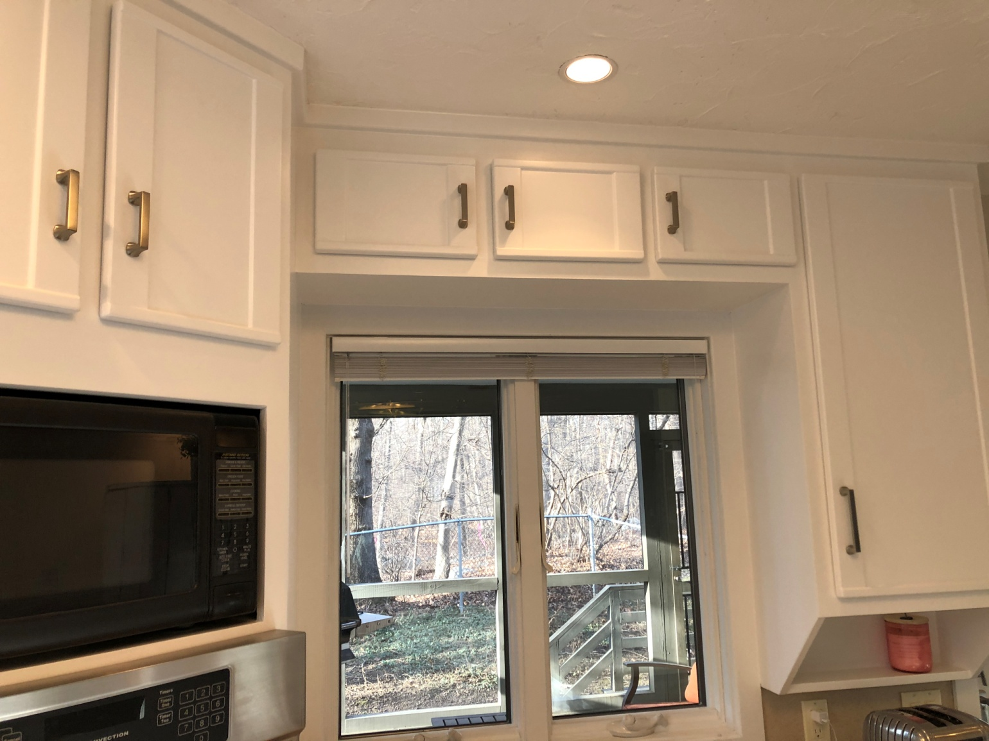

DON'T INCLUDE PAINTING INSIDE THE CABINET.
CABINETS:
COLOR SAME LIKE WITE DOORS 31Unit
STYLE OAK-WOOD FOR SMOOTH DRAWERS 11 Unit
COMPLETE JOB IN 3 WEEKS

We use only the highest quality materials.
” Thank you so much for trusting me . I do my best, taking care of your house as if it were mine. I take pleasure and love my job. “
Wellington B. Bovenschulte
Master Painter
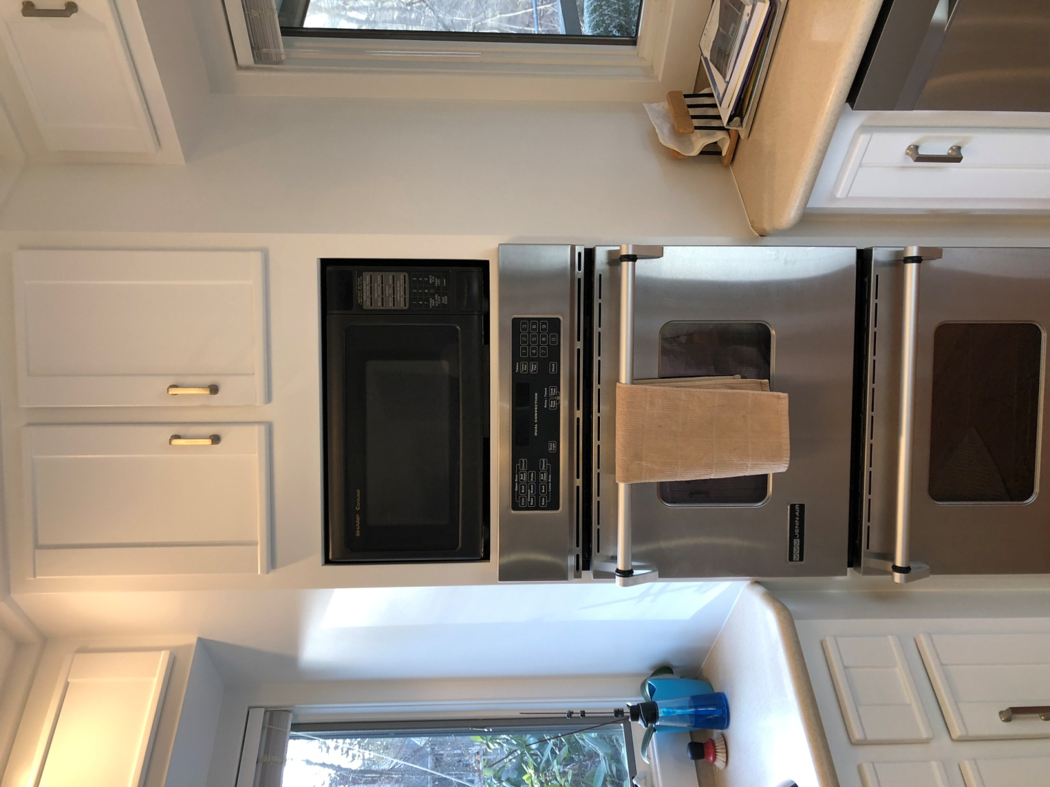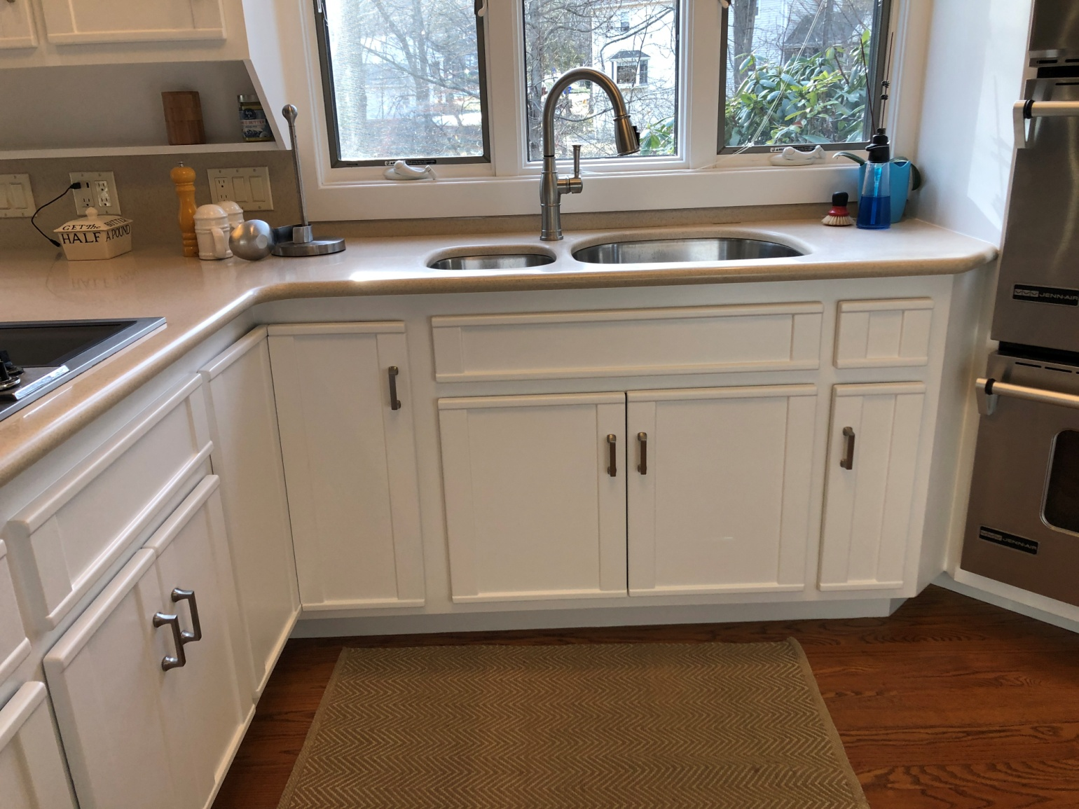

DON'T INCLUDE PAINTING INSIDE THE CABINET.
CABINETS:
COLOR SAME LIKE WITE DOORS 31Unit
STYLE OAK-WOOD FOR SMOOTH DRAWERS 11 Unit
COMPLETE JOB IN 3 WEEKS

We use only the highest quality materials.
” Thank you so much for trusting me . I do my best, taking care of your house as if it were mine. I take pleasure and love my job. “
Wellington B. Bovenschulte
Master Painter
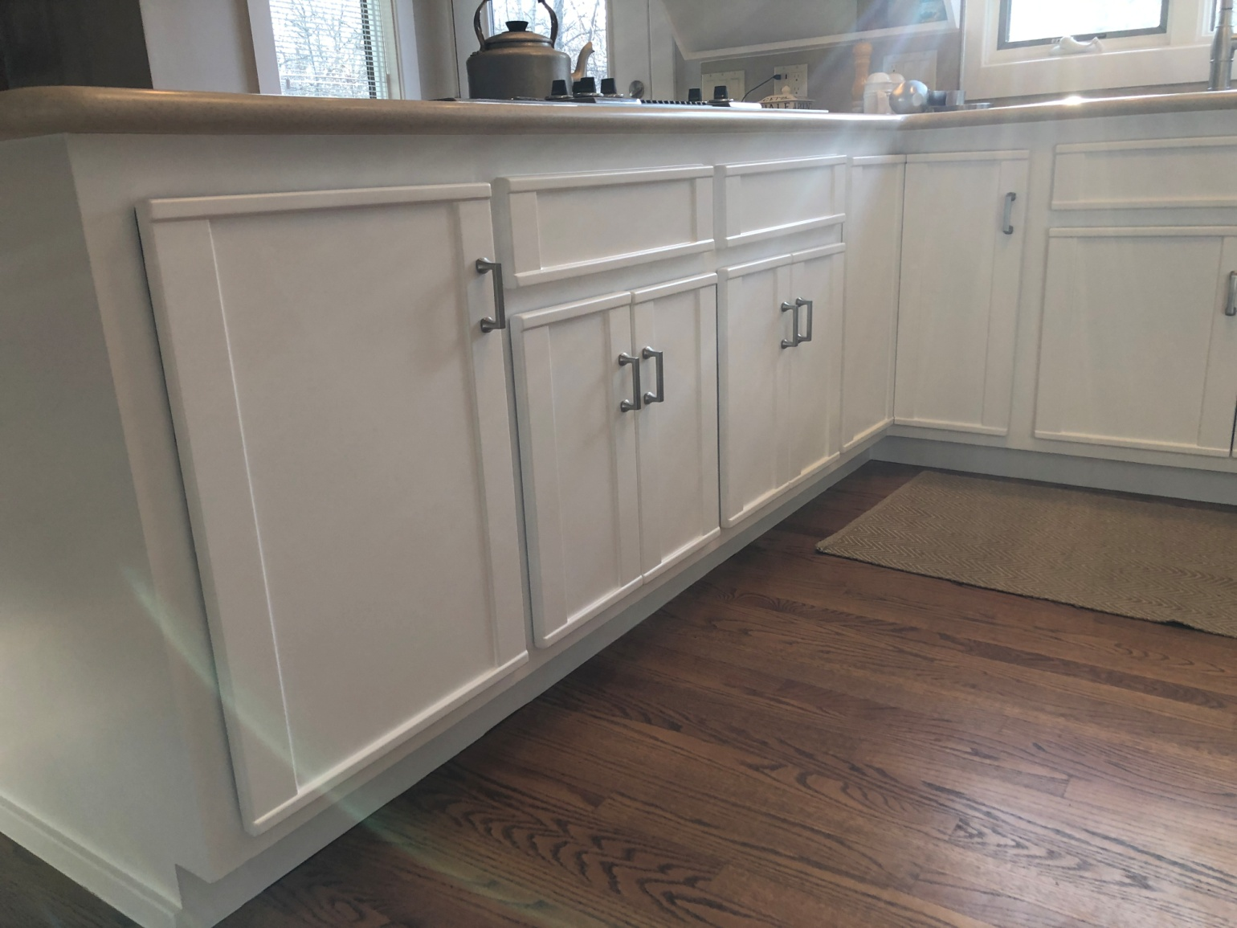

DON'T INCLUDE PAINTING INSIDE THE CABINET.
CABINETS:
COLOR SAME LIKE WITE DOORS 31Unit
STYLE OAK-WOOD FOR SMOOTH DRAWERS 11 Unit
COMPLETE JOB IN 3 WEEKS

We use only the highest quality materials.
” Thank you so much for trusting me . I do my best, taking care of your house as if it were mine. I take pleasure and love my job. “
Wellington B. Bovenschulte
Master Painter
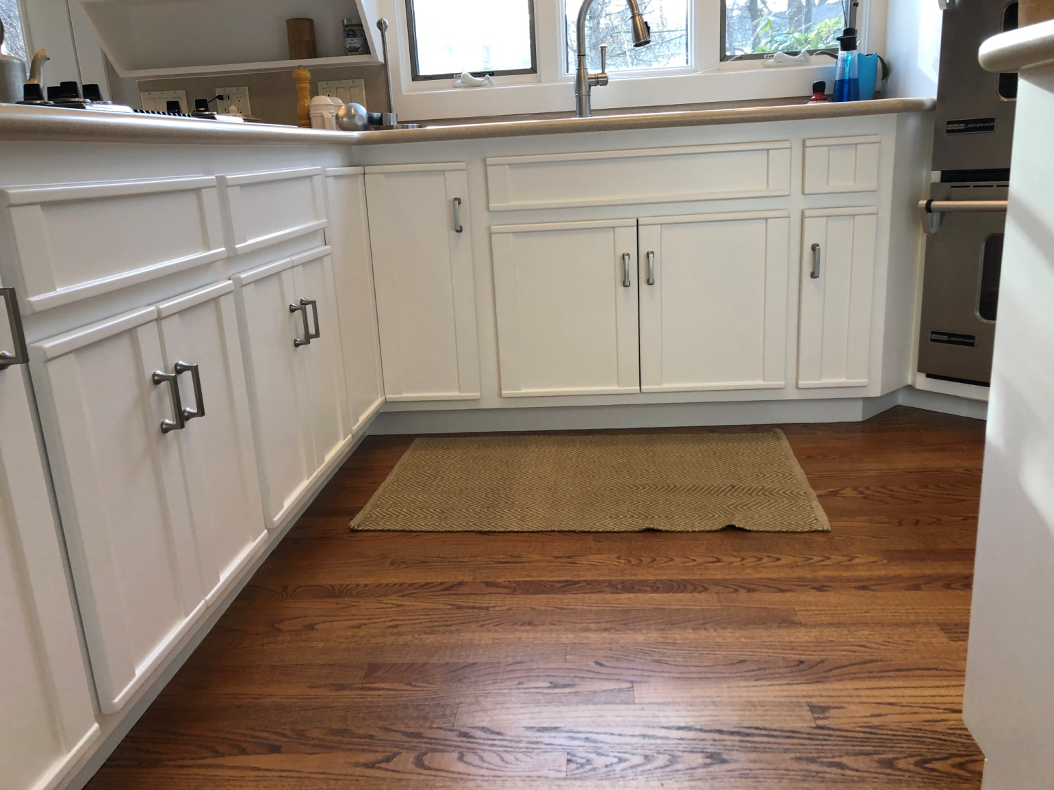

DON'T INCLUDE PAINTING INSIDE THE CABINET.
CABINETS:
COLOR SAME LIKE WITE DOORS 31Unit
STYLE OAK-WOOD FOR SMOOTH DRAWERS 11 Unit
COMPLETE JOB IN 3 WEEKS

We use only the highest quality materials.
” Thank you so much for trusting me . I do my best, taking care of your house as if it were mine. I take pleasure and love my job. “
Wellington B. Bovenschulte
Master Painter
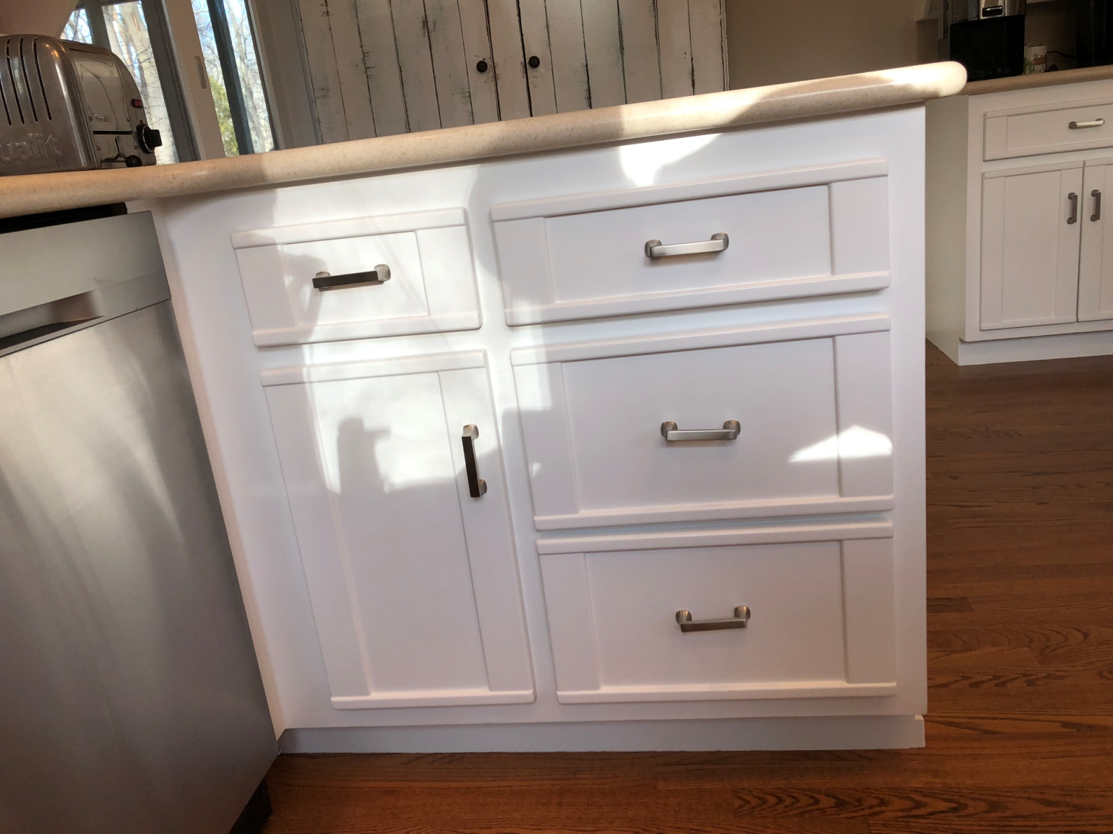

DON'T INCLUDE PAINTING INSIDE THE CABINET.
CABINETS:
COLOR SAME LIKE WITE DOORS 31Unit
STYLE OAK-WOOD FOR SMOOTH DRAWERS 11 Unit
COMPLETE JOB IN 3 WEEKS

We use only the highest quality materials.
” Thank you so much for trusting me . I do my best, taking care of your house as if it were mine. I take pleasure and love my job. “
Wellington B. Bovenschulte
Master Painter
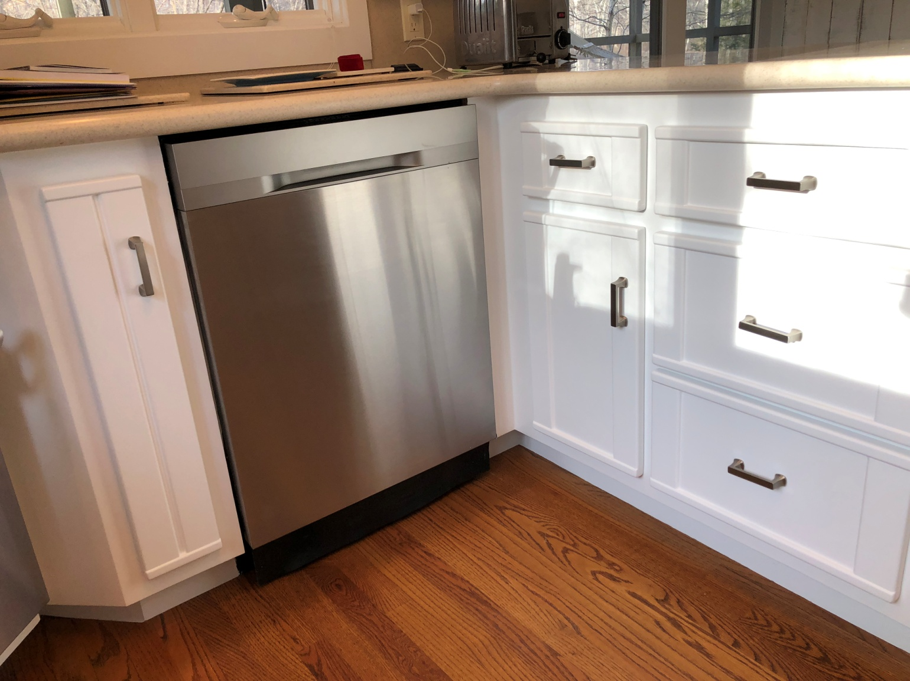

DON'T INCLUDE PAINTING INSIDE THE CABINET.
CABINETS:
COLOR SAME LIKE WITE DOORS 31Unit
STYLE OAK-WOOD FOR SMOOTH DRAWERS 11 Unit
COMPLETE JOB IN 3 WEEKS

We use only the highest quality materials.
” Thank you so much for trusting me . I do my best, taking care of your house as if it were mine. I take pleasure and love my job. “
Wellington B. Bovenschulte
Master Painter
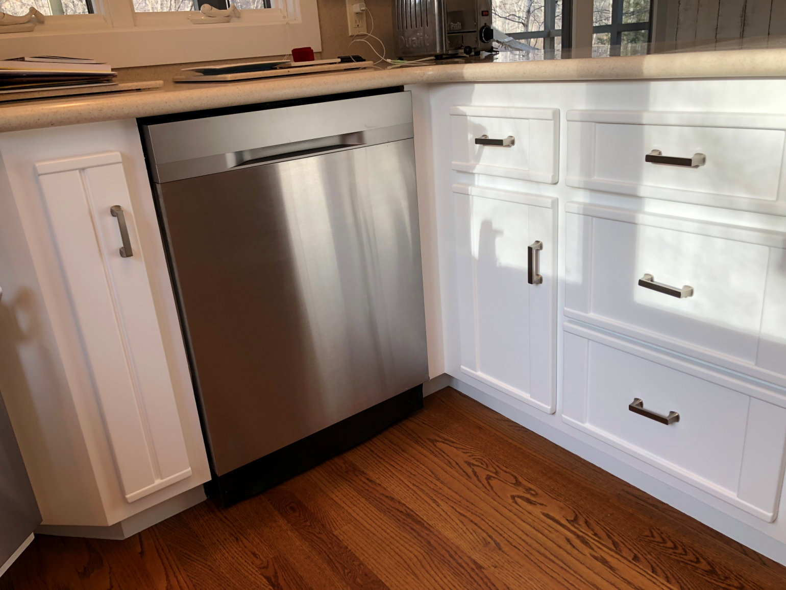

DON'T INCLUDE PAINTING INSIDE THE CABINET.
CABINETS:
COLOR SAME LIKE WITE DOORS 31Unit
STYLE OAK-WOOD FOR SMOOTH DRAWERS 11 Unit
COMPLETE JOB IN 3 WEEKS

We use only the highest quality materials.
” Thank you so much for trusting me . I do my best, taking care of your house as if it were mine. I take pleasure and love my job. “
Wellington B. Bovenschulte
Master Painter
THANK YOU!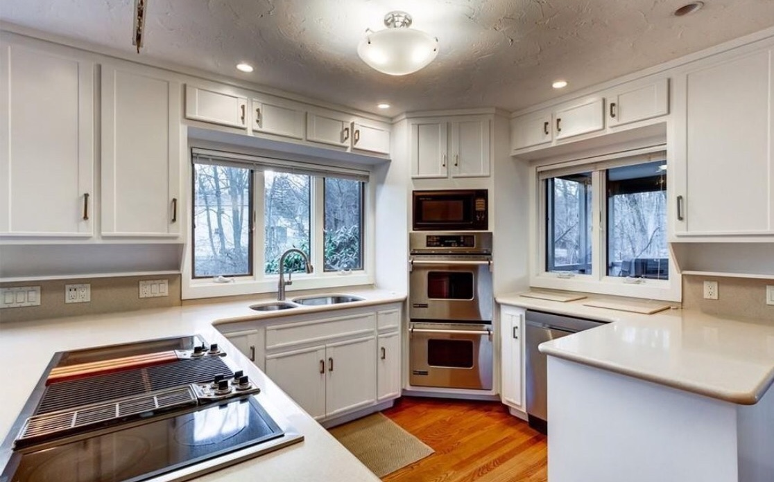

DON'T INCLUDE PAINTING INSIDE THE CABINET.
CABINETS:
COLOR SAME LIKE WITE DOORS 31Unit
STYLE OAK-WOOD FOR SMOOTH DRAWERS 11 Unit
COMPLETE JOB IN 3 WEEKS

We use only the highest quality materials.
” Thank you so much for trusting me . I do my best, taking care of your house as if it were mine. I take pleasure and love my job. “
Wellington B. Bovenschulte
Master Painter
THANK YOU!
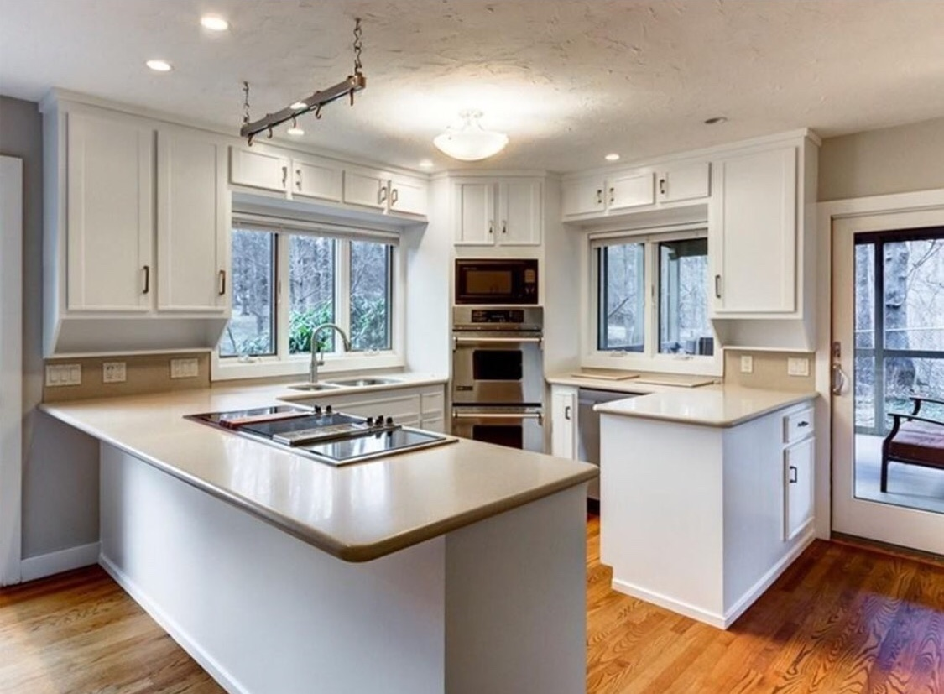

DON'T INCLUDE PAINTING INSIDE THE CABINET.
CABINETS:
COLOR SAME LIKE WITE DOORS 31Unit
STYLE OAK-WOOD FOR SMOOTH DRAWERS 11 Unit
COMPLETE JOB IN 3 WEEKS

We use only the highest quality materials.
” Thank you so much for trusting me . I do my best, taking care of your house as if it were mine. I take pleasure and love my job. “
Wellington B. Bovenschulte
Master Painter
THANK YOU!
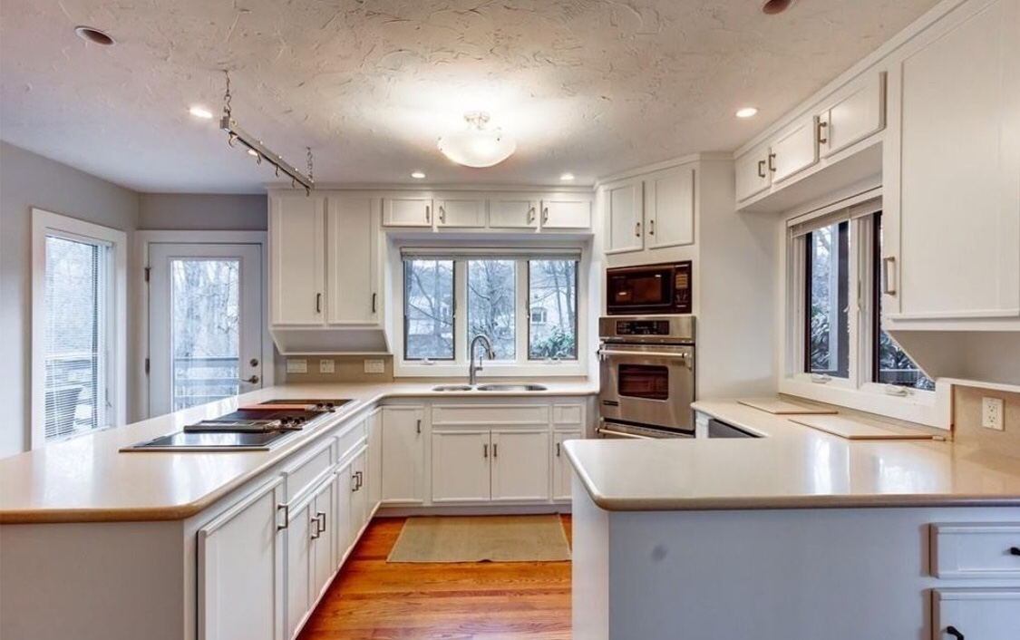

DON'T INCLUDE PAINTING INSIDE THE CABINET.
CABINETS:
COLOR SAME LIKE WITE DOORS 31Unit
STYLE OAK-WOOD FOR SMOOTH DRAWERS 11 Unit
COMPLETE JOB IN 3 WEEKS

We use only the highest quality materials.
” Thank you so much for trusting me . I do my best, taking care of your house as if it were mine. I take pleasure and love my job. “
Wellington B. Bovenschulte
Master Painter
THANK YOU!

